Cognitive reappraisal cards

This game contains:
- 12 cards with situations and accompanying thought (use in Phase 2)
- 14 cards with situations (use in Phase 3)

S1: Parrot Coco has been sent out of the classroom a few times. Her parents got angry about this and she got grounded for two weeks.

Thought: My parents do not care about me. How they treat me is so unfair.

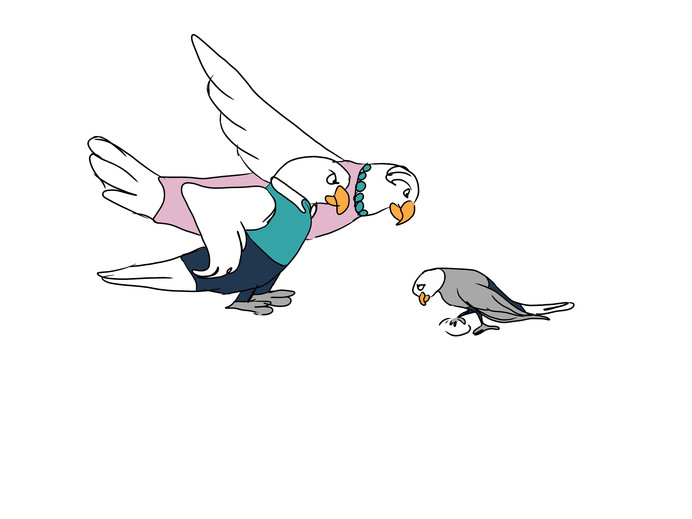
-------------------------------------------------------------------------------------------------------------------------------

S1: Parrot Coco has been sent out of the classroom a few times. Her parents got angry about this and she got grounded for two weeks.

Thought: My parents punish me because they want me to learn from my mistake and not because they do not care about me.

S2: Parrot Pedro got a 4/10 for his English test.
Thought: I am a loser. You see, I cannot learn that well. I might as well quit school. I will never pass my final exam!

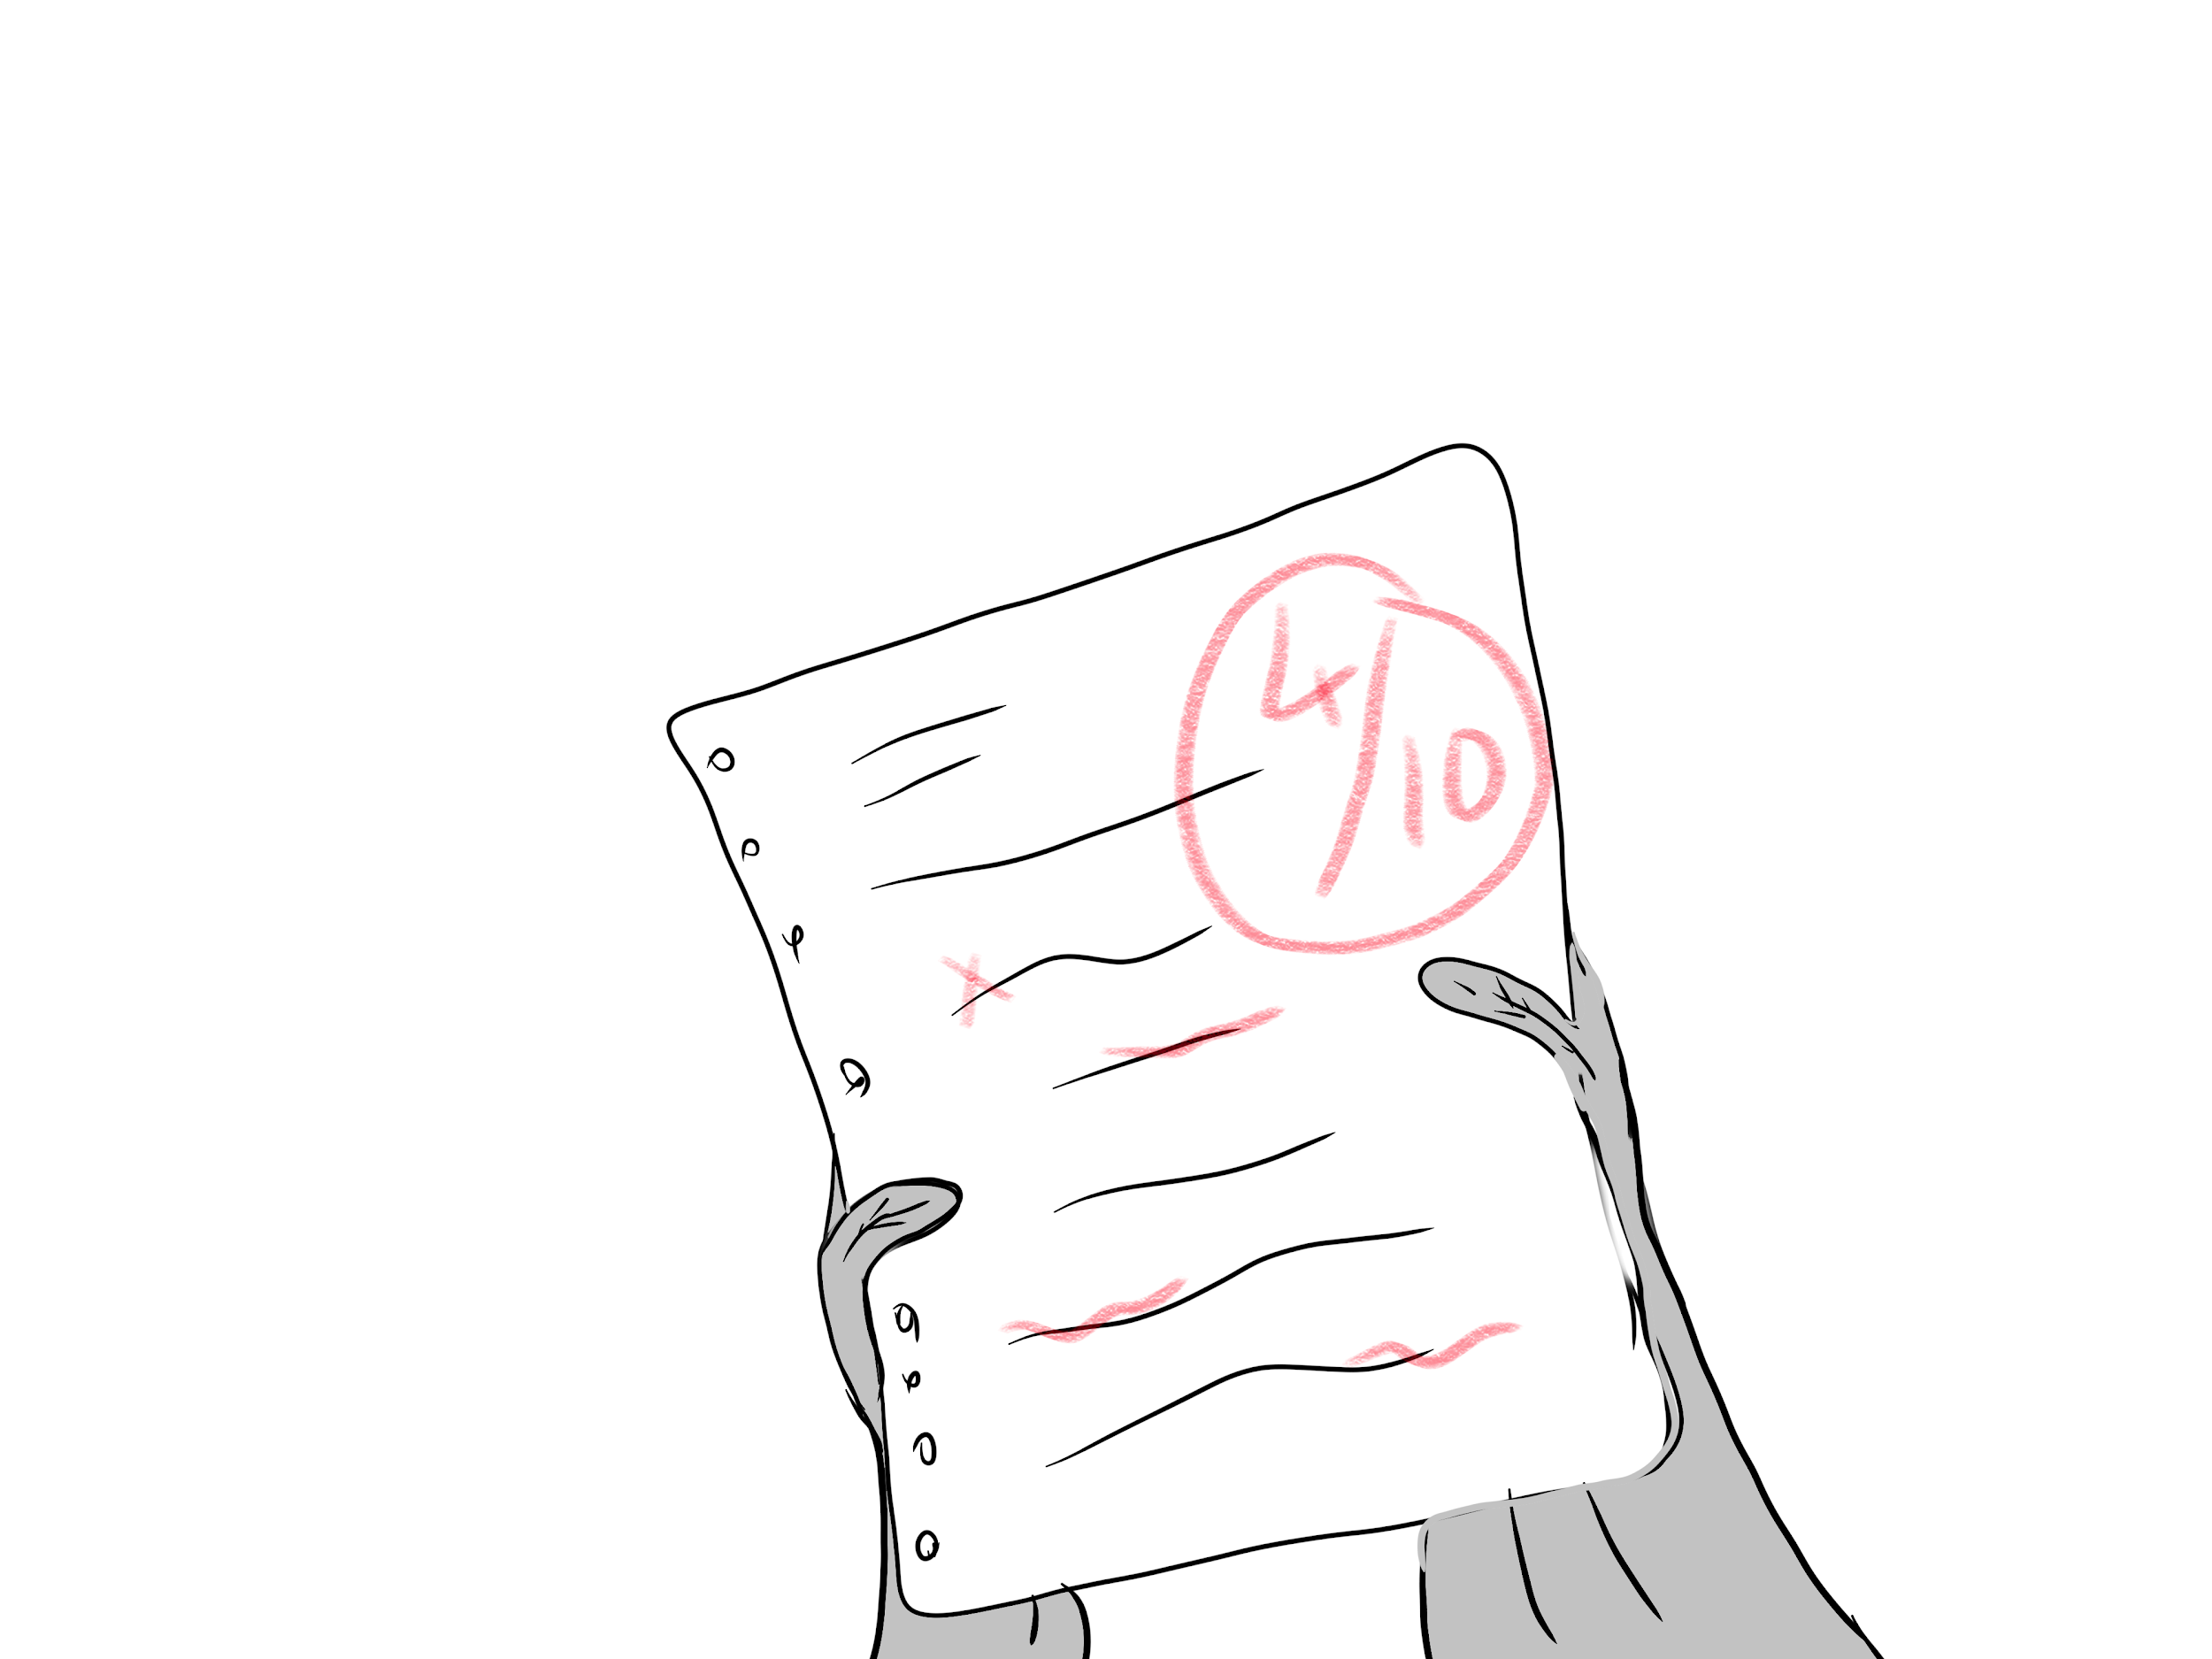

-------------------------------------------------------------------------------------------------------------------------------

S2: Parrot Pedro got a 4/10 for his English test.
Thought: I did study well, but the test was very difficult.

S3: Parrot Paula saw a classmate from last year in the hallway, but the classmate did not say anything or look at her.
Thought: She does not like me enough. She already forgot about me.
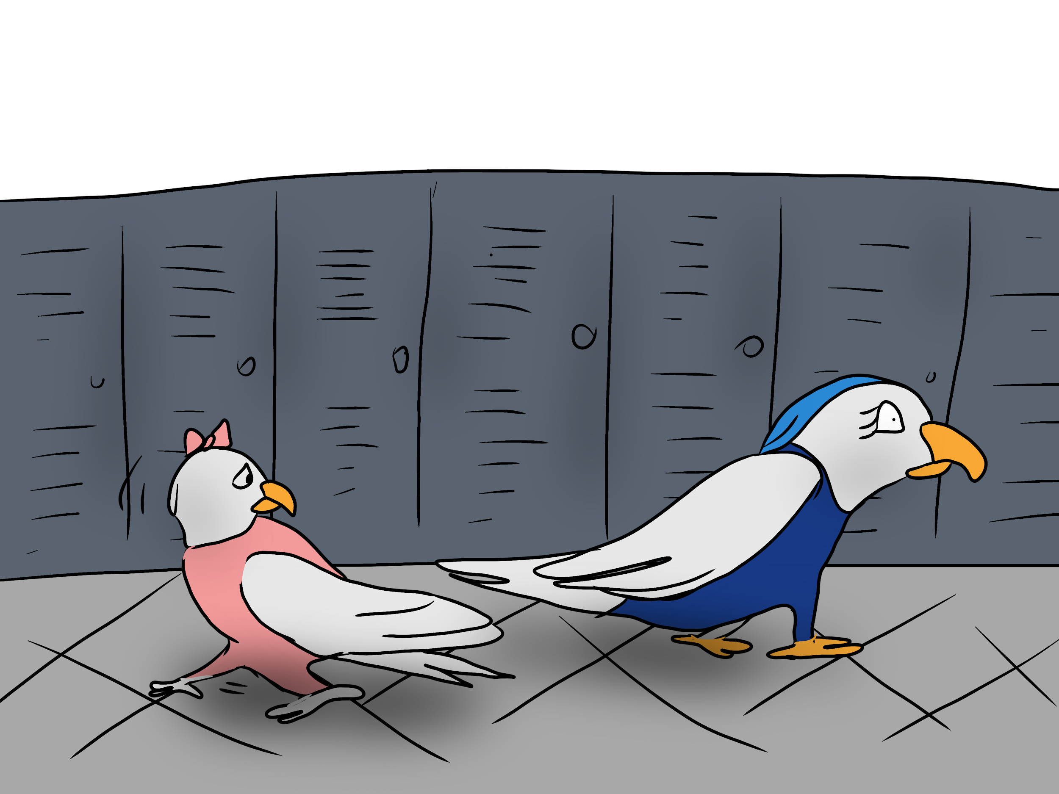

-------------------------------------------------------------------------------------------------------------------------------

S3: Parrot Paula saw a classmate from last year in the hallway, but the classmate did not say anything or look at her.
Thought: There is not really a reason why she would have stopped liking me. I guess she just did not see me. Next time I will say hi to her.

S4: Parrot Lizzy had a day out at a theme park. The teacher asks how it was.
Thought: It was a stupid trip. We had to wait 40 minutes for the rollercoaster.

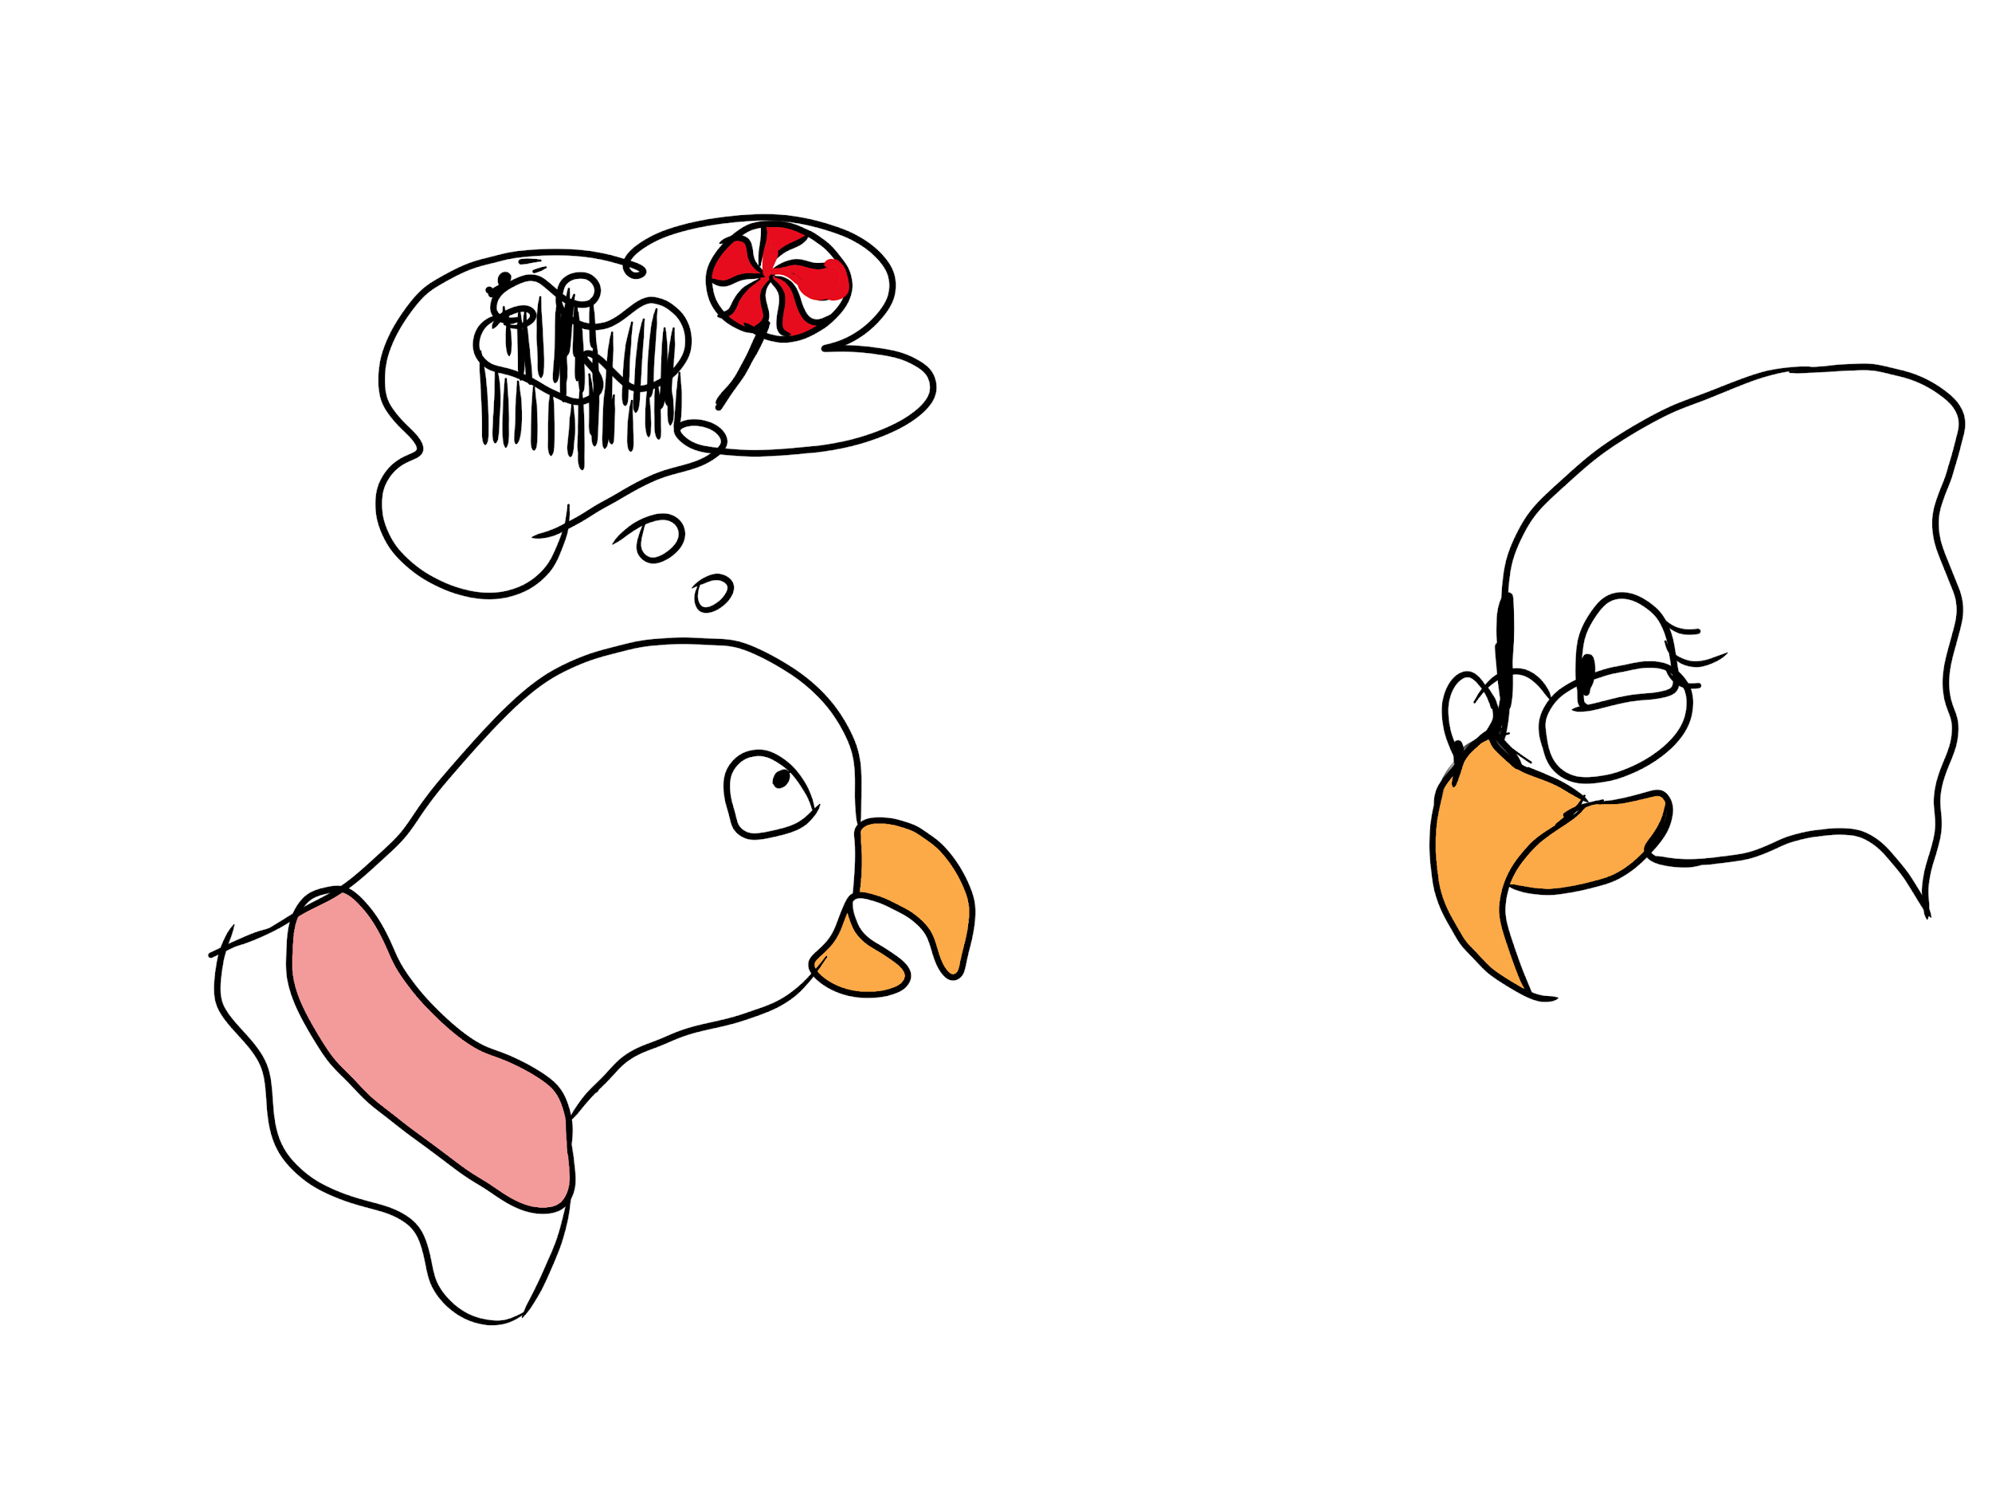

-------------------------------------------------------------------------------------------------------------------------------

S4: Parrot Lizzy had a day out at a theme park. The teacher asks how it was.
Thought: It was not a stupid trip. Even though the wait was annoying, all the other activities were a lot of fun.

S5: Parrot Bobby borrowed Luke’s football and the football got a puncture.
Thought: I am so clumsy. It is my fault that the football is now useless. I must have done something wrong. Luke is going to be angry.

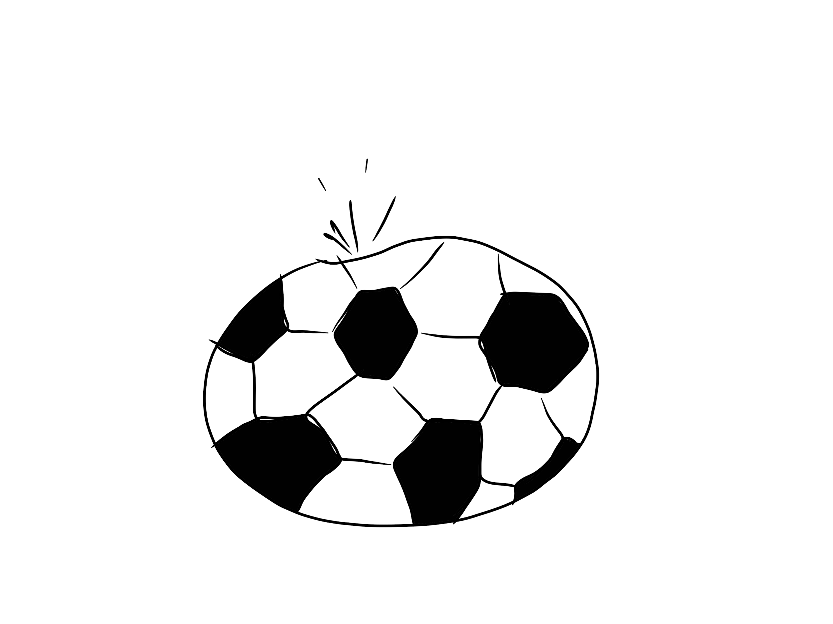

-------------------------------------------------------------------------------------------------------------------------------

S5: Parrot Bobby borrowed Luke’s football and the football got a puncture.
Thought: Accidents like this happen to everyone.

S6: Parrot Coco worked together with some other classmates on an assignment and they got a disappointing grade.
Thought: It is all their fault. They are so stupid!
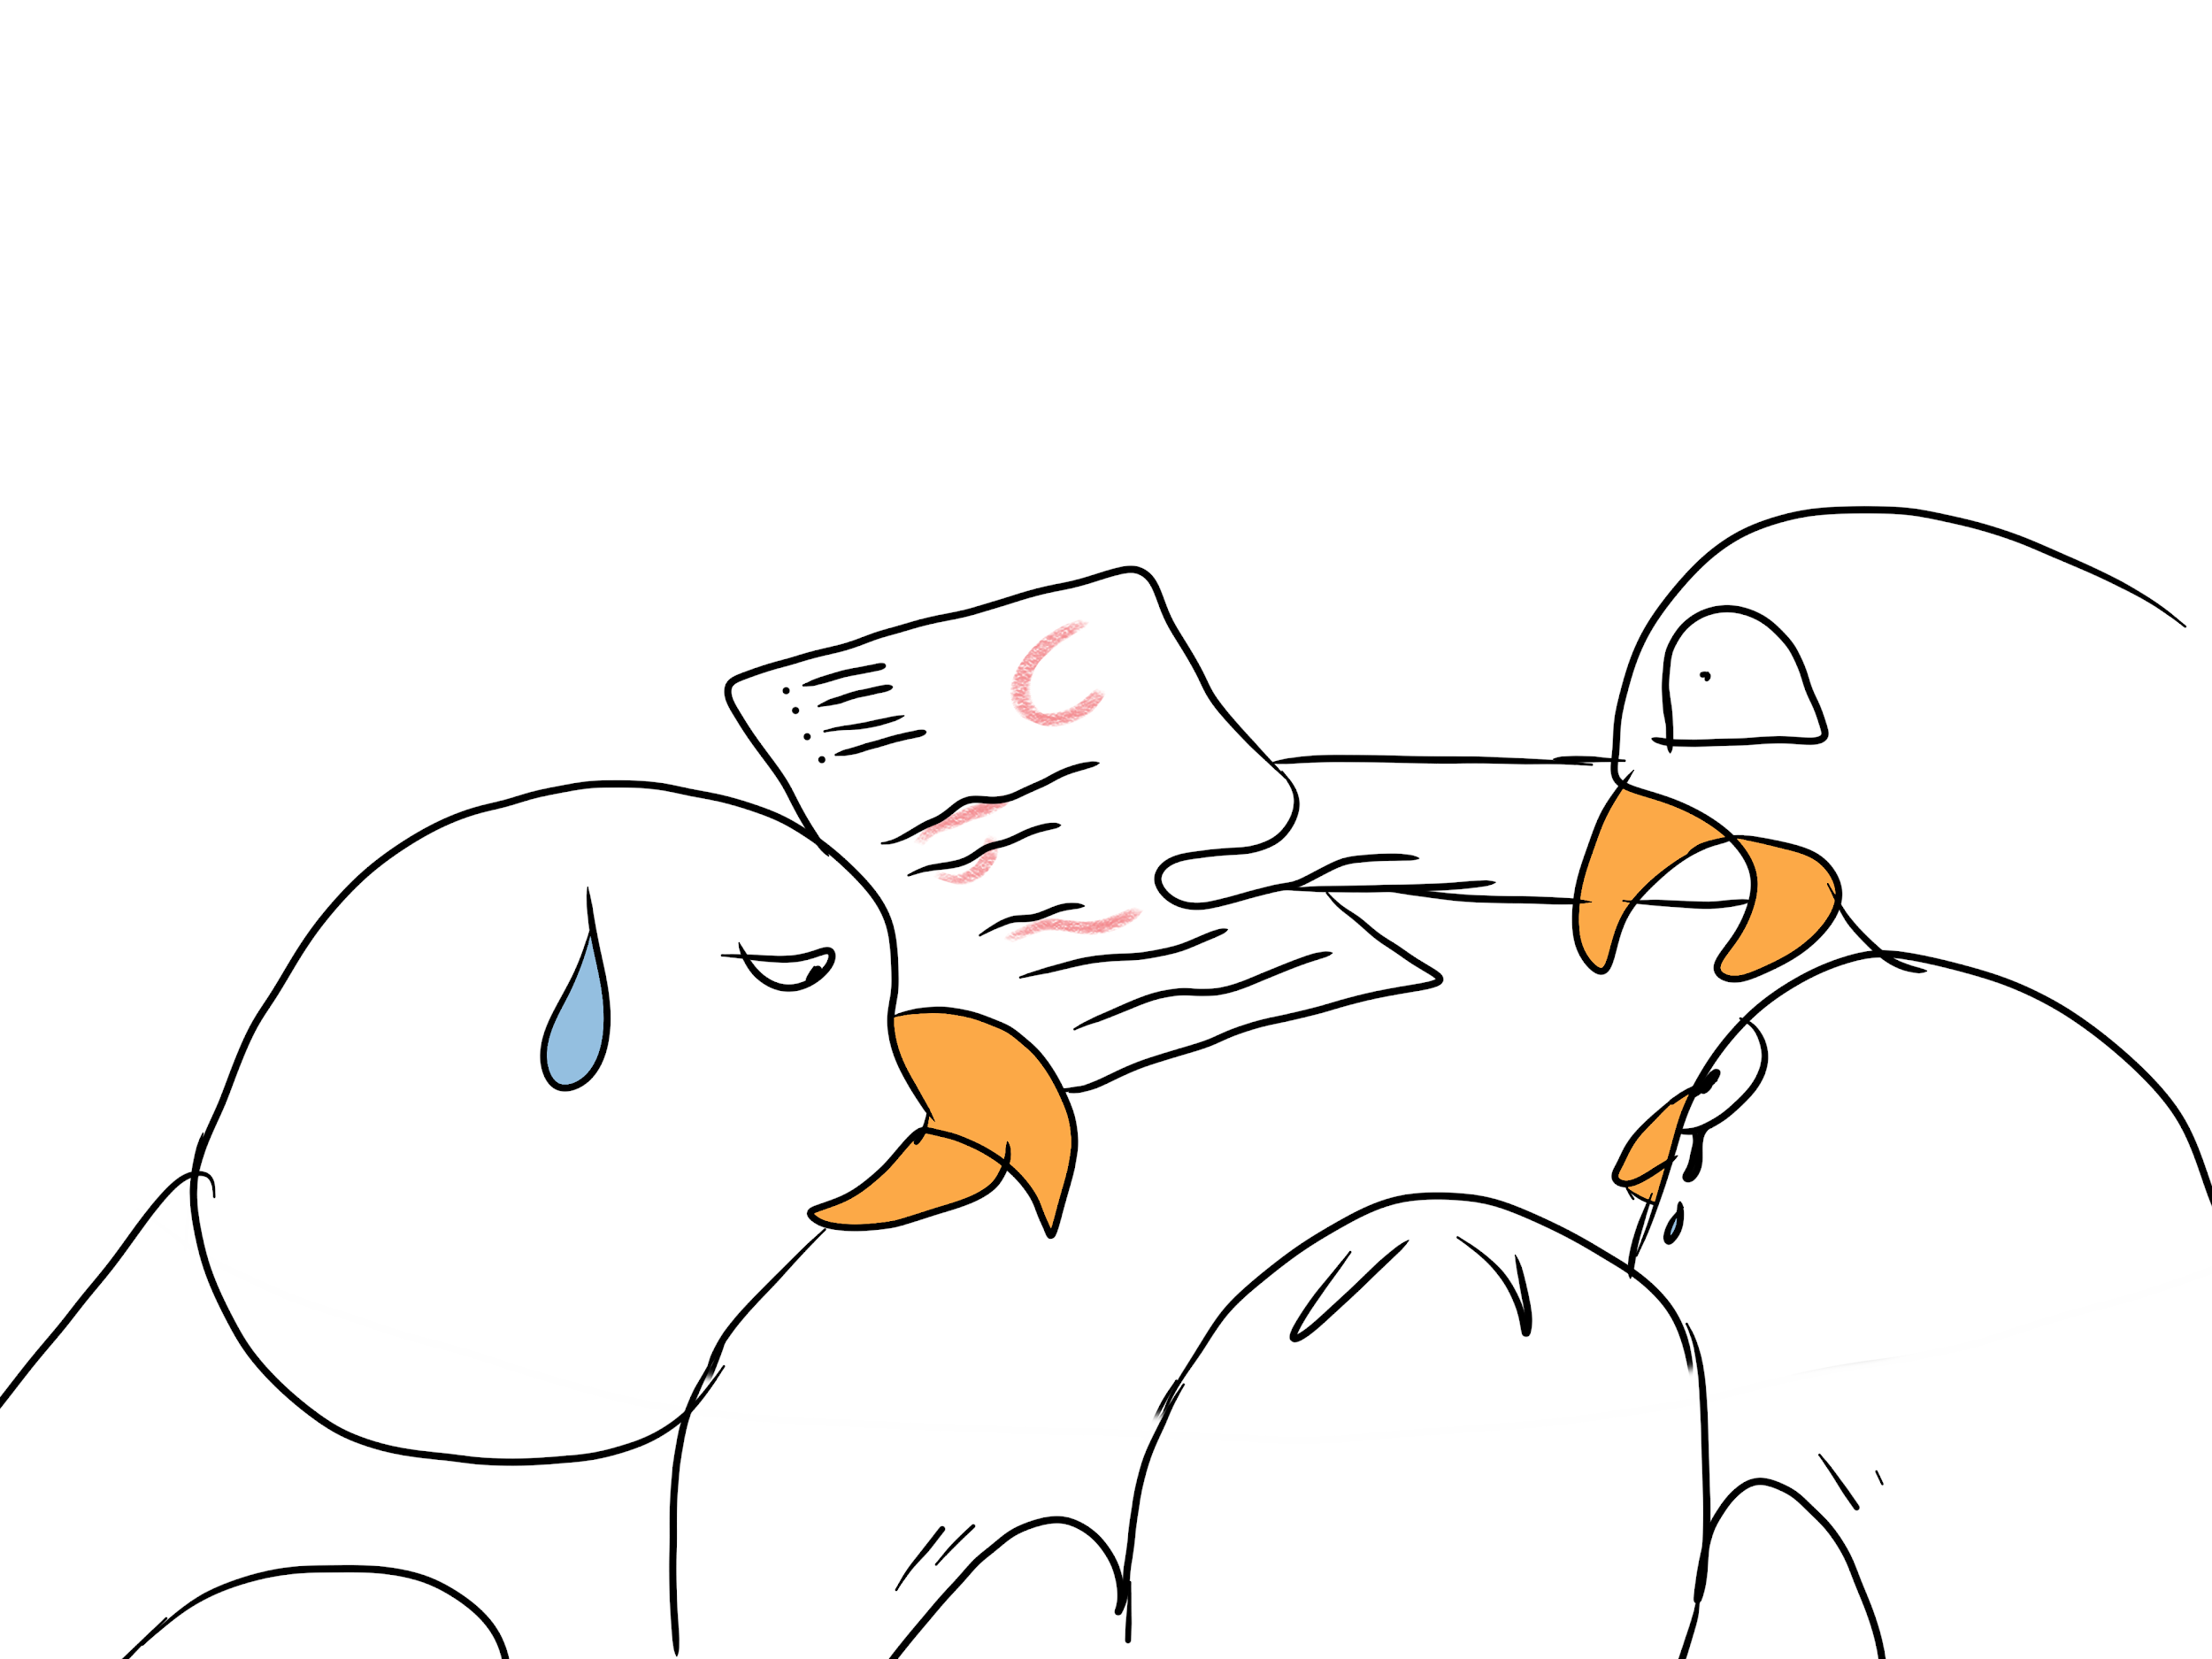

-------------------------------------------------------------------------------------------------------------------------------

S6: Parrot Coco worked together with some other classmates on an assignment and they got a disappointing grade.
Thought: Maybe I overlooked something myself in the assignment or maybe we should have divided the tasks better.

Parrot Pedro has to do a mathematics test tomorrow.

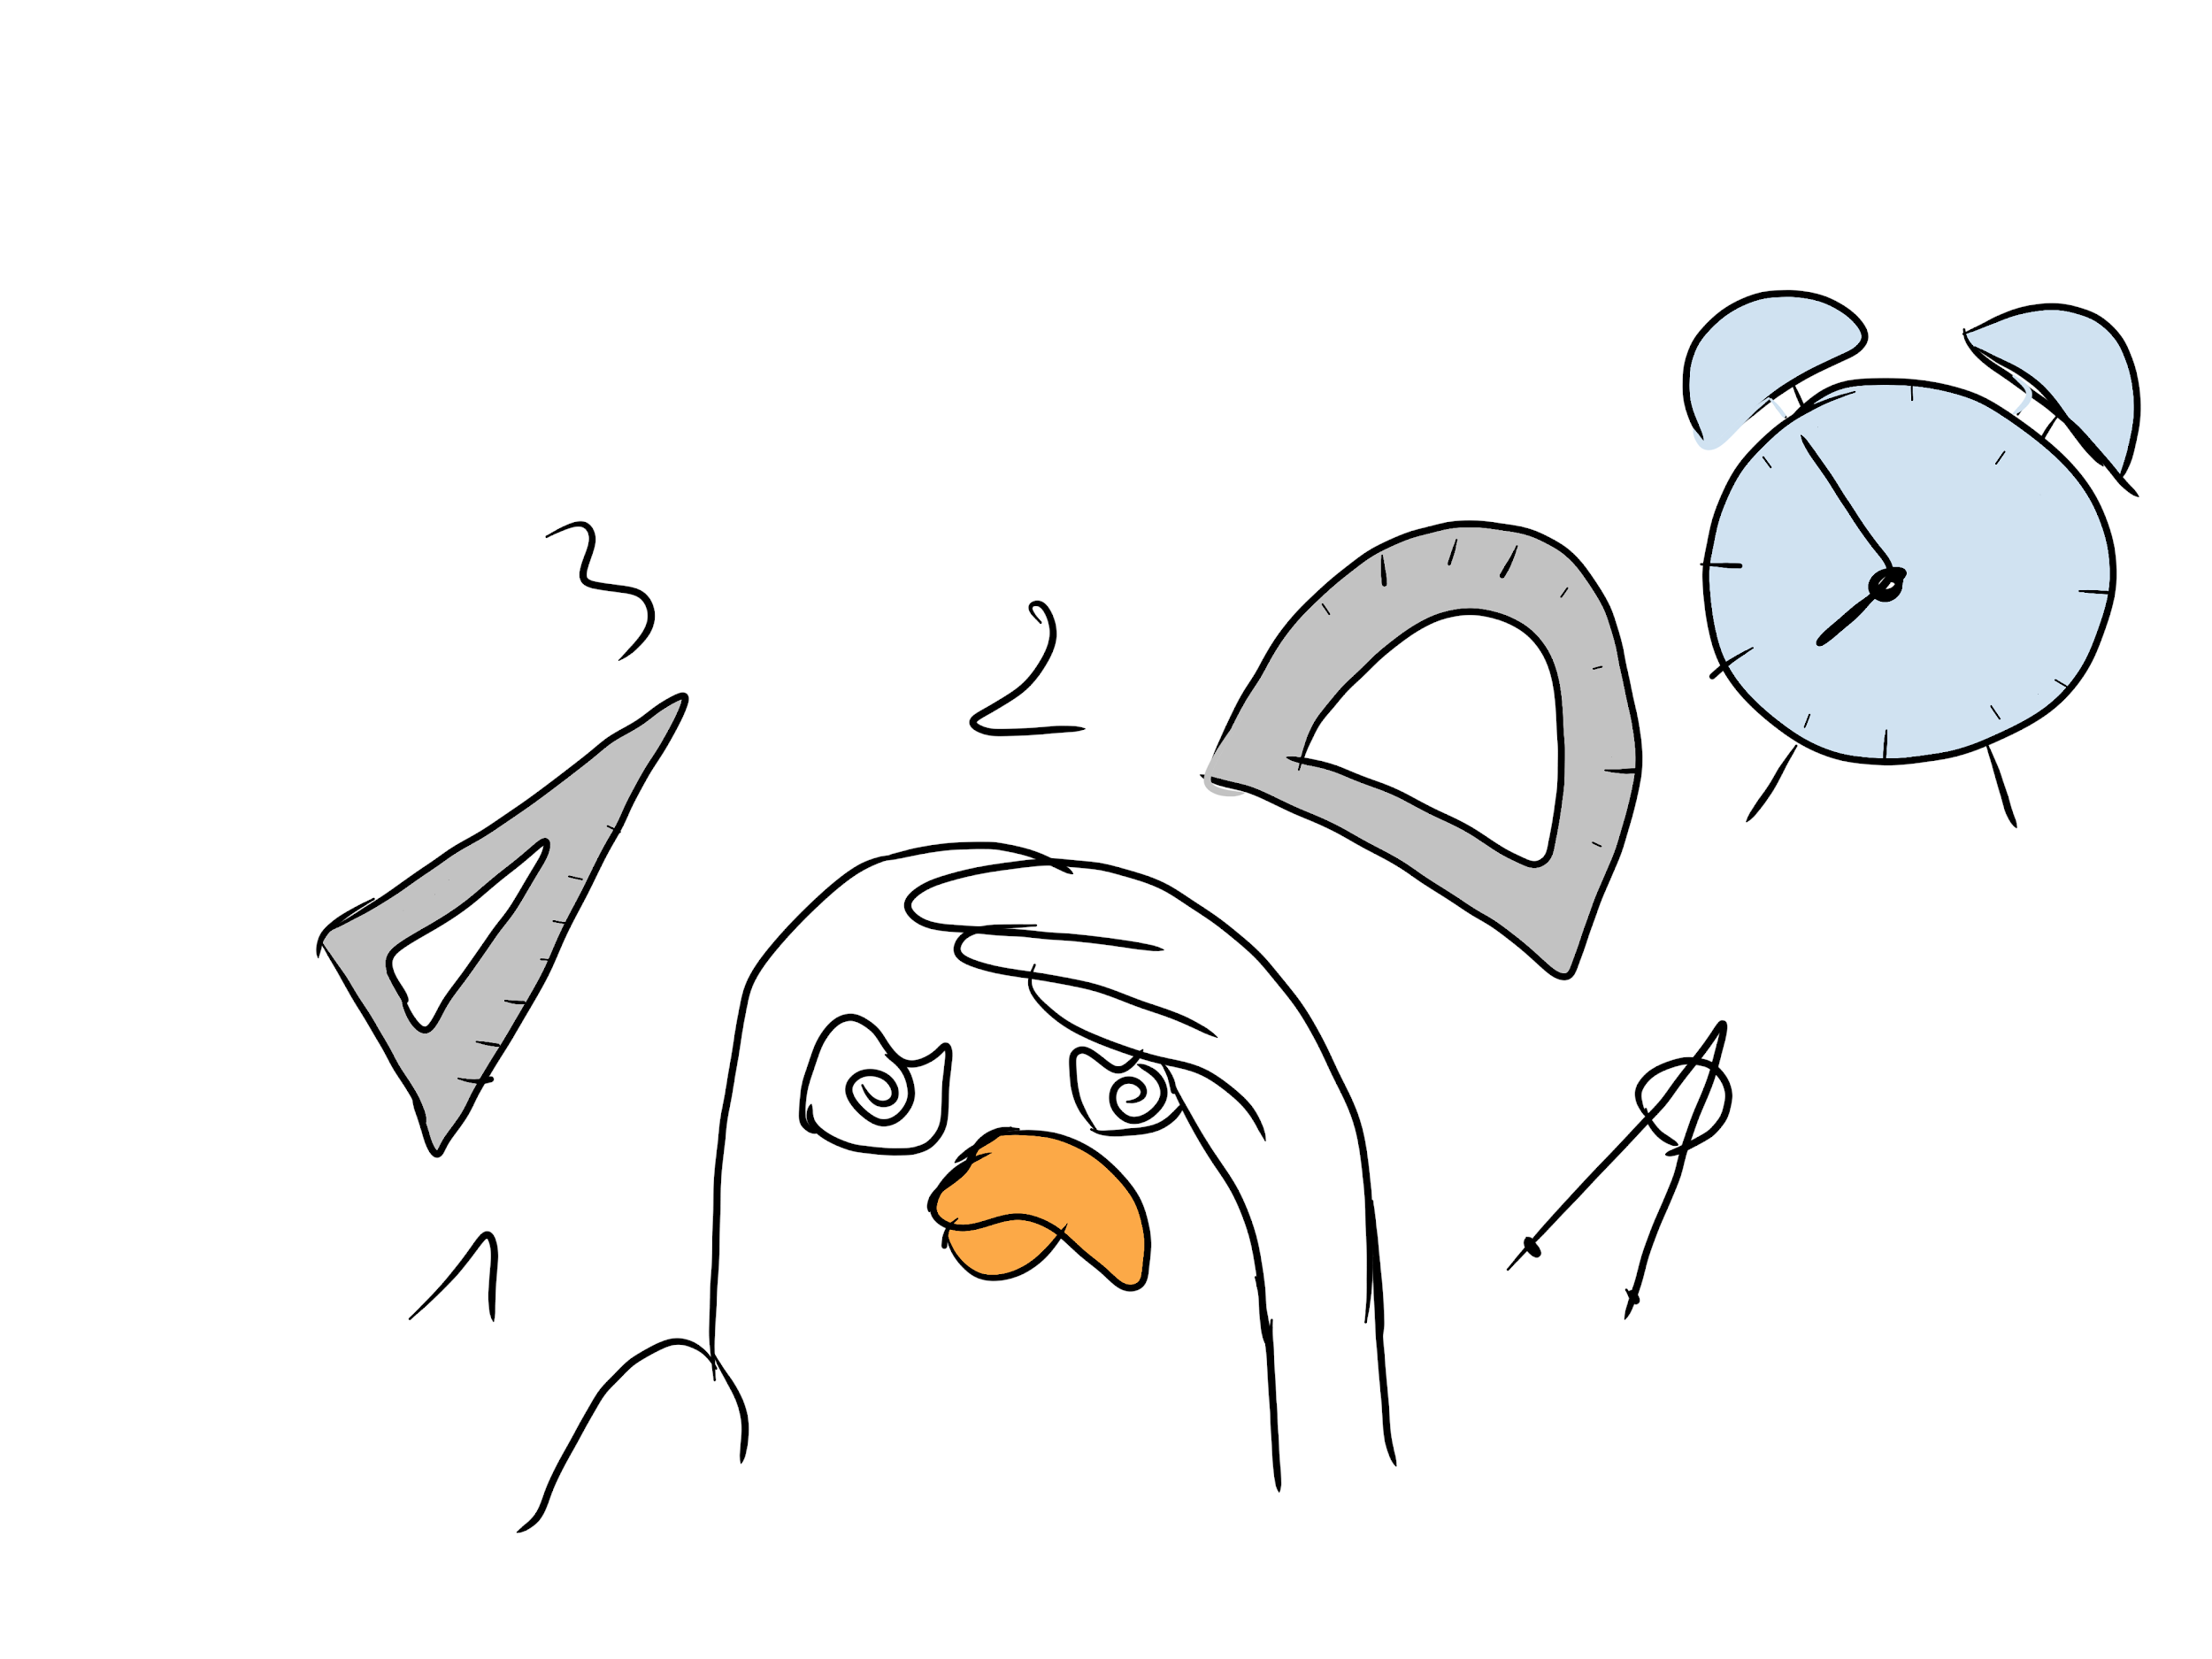

-------------------------------------------------------------------------------------------------------------------------------

Parrot Paula did not receive an invitation to Sabine’s party, whereas many other classmates were invited.

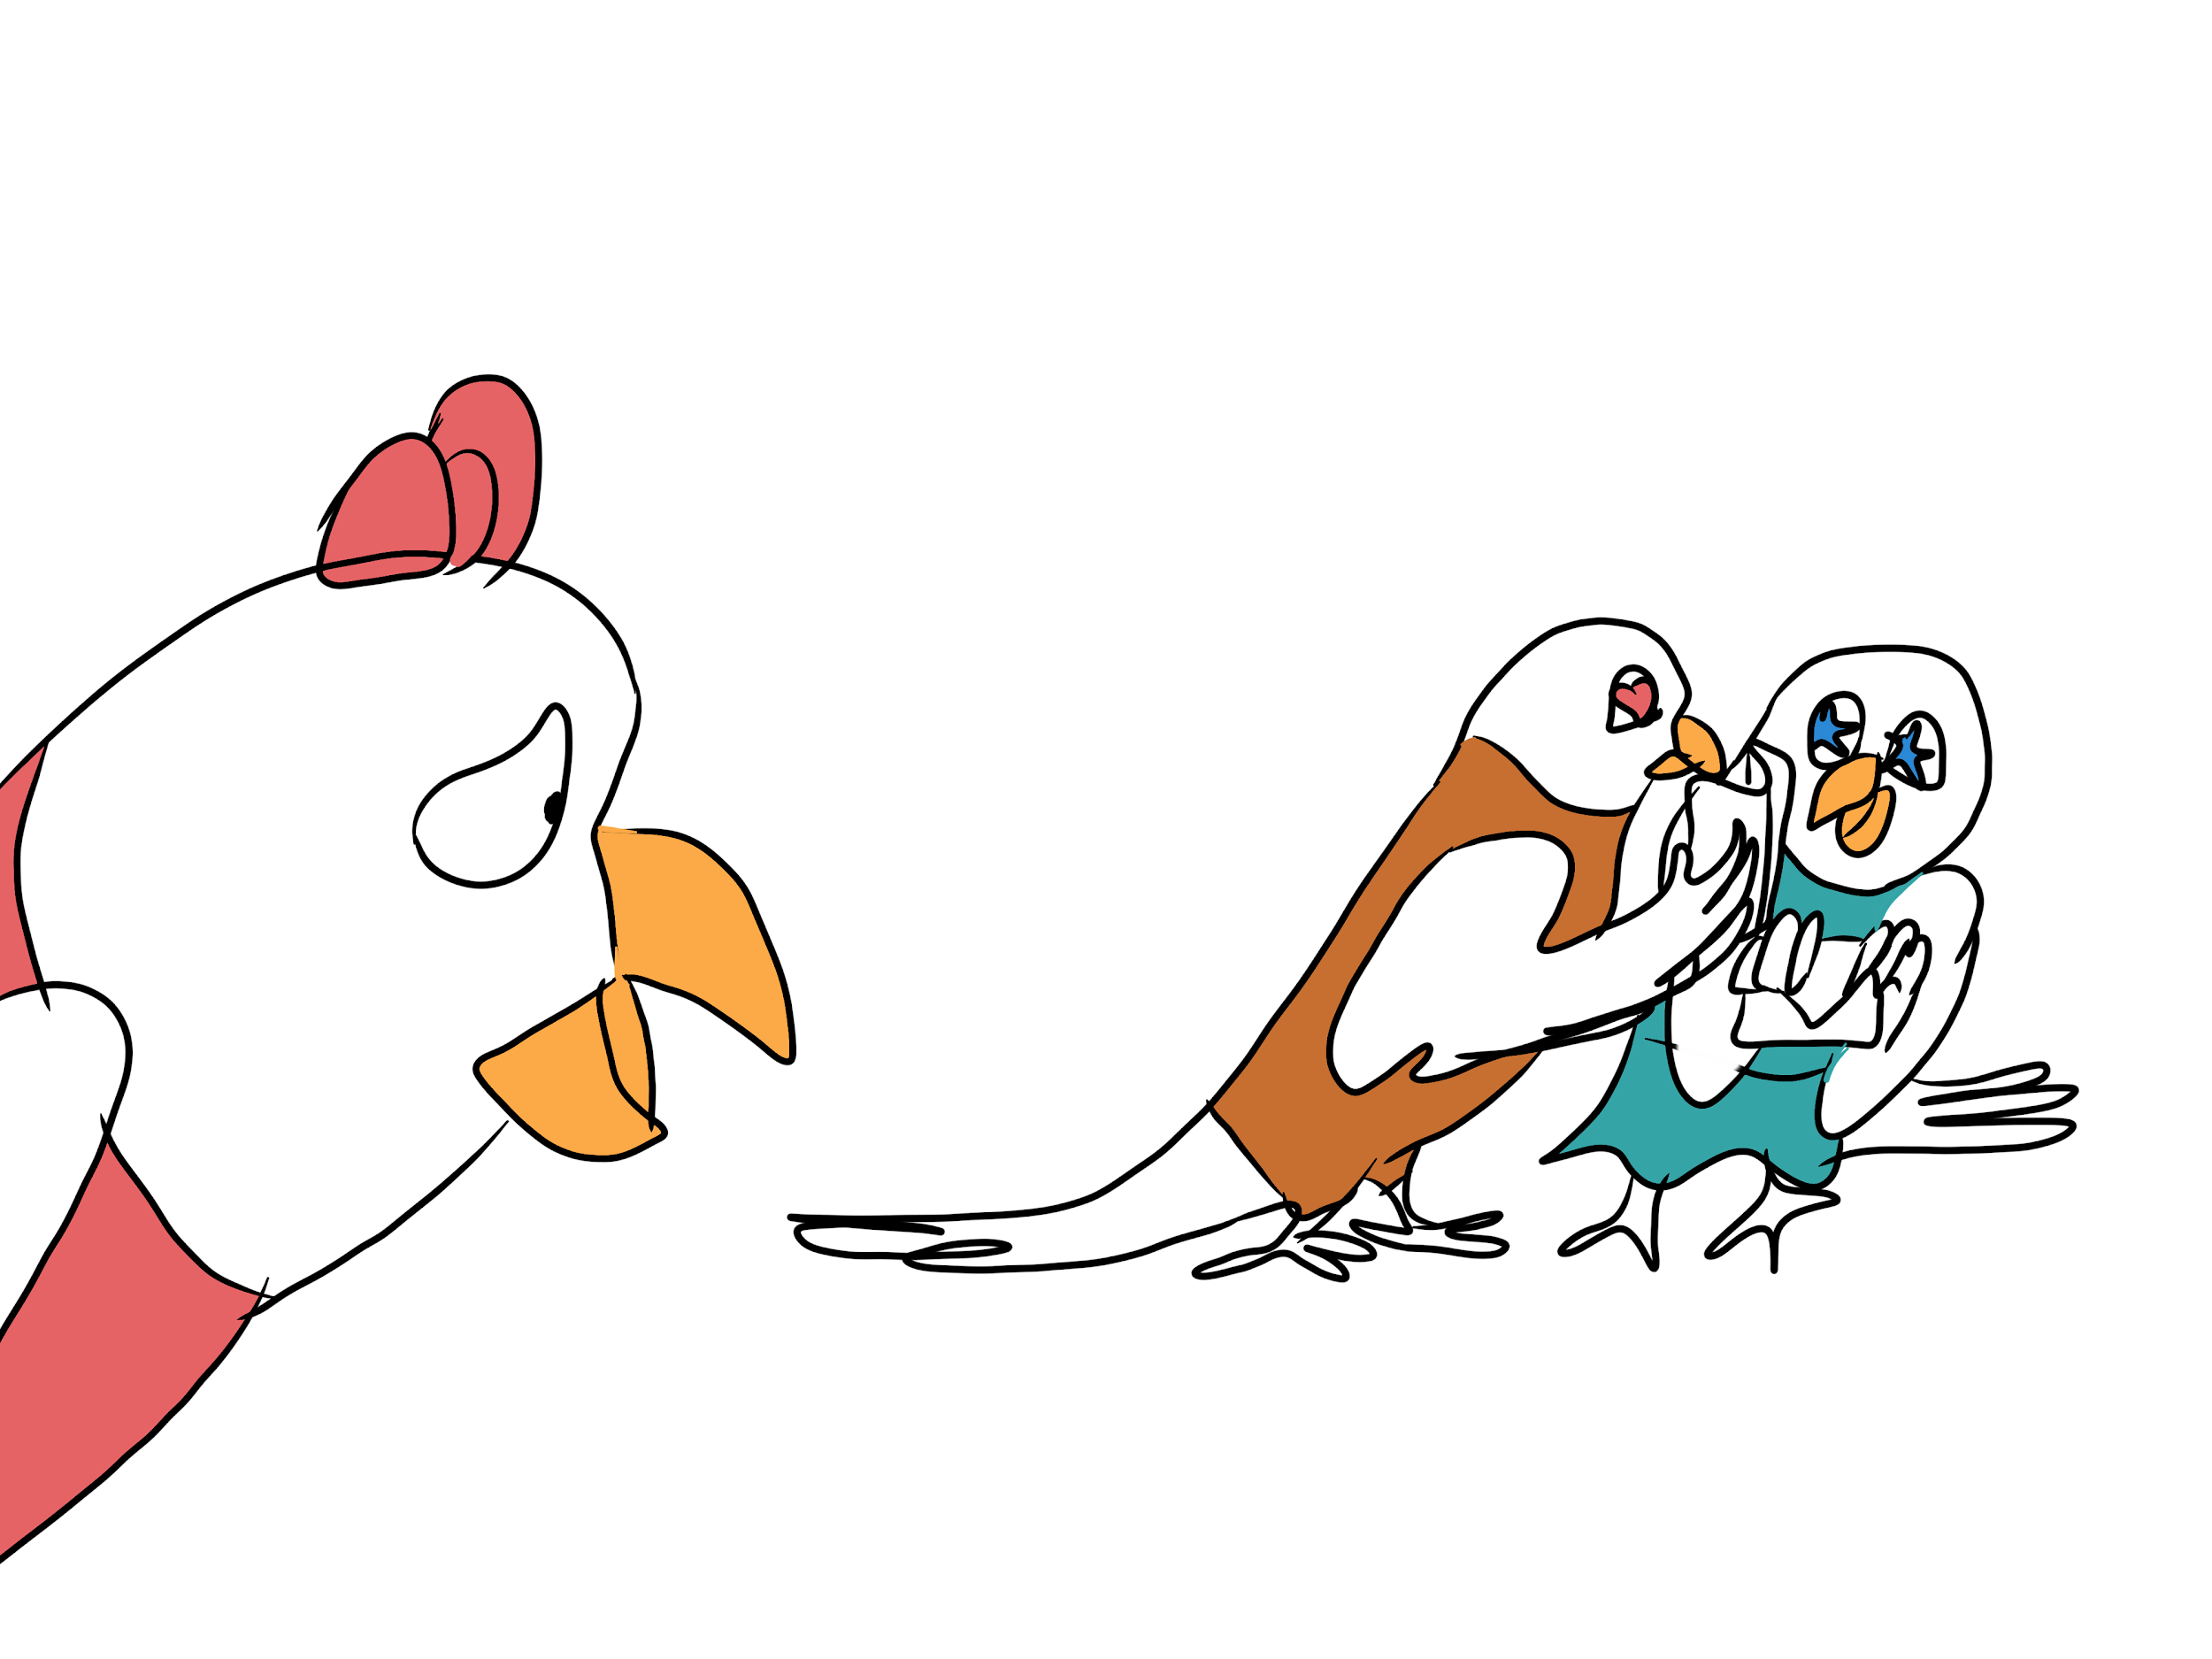

Parrot Coco doesn’t want to go to school this morning.
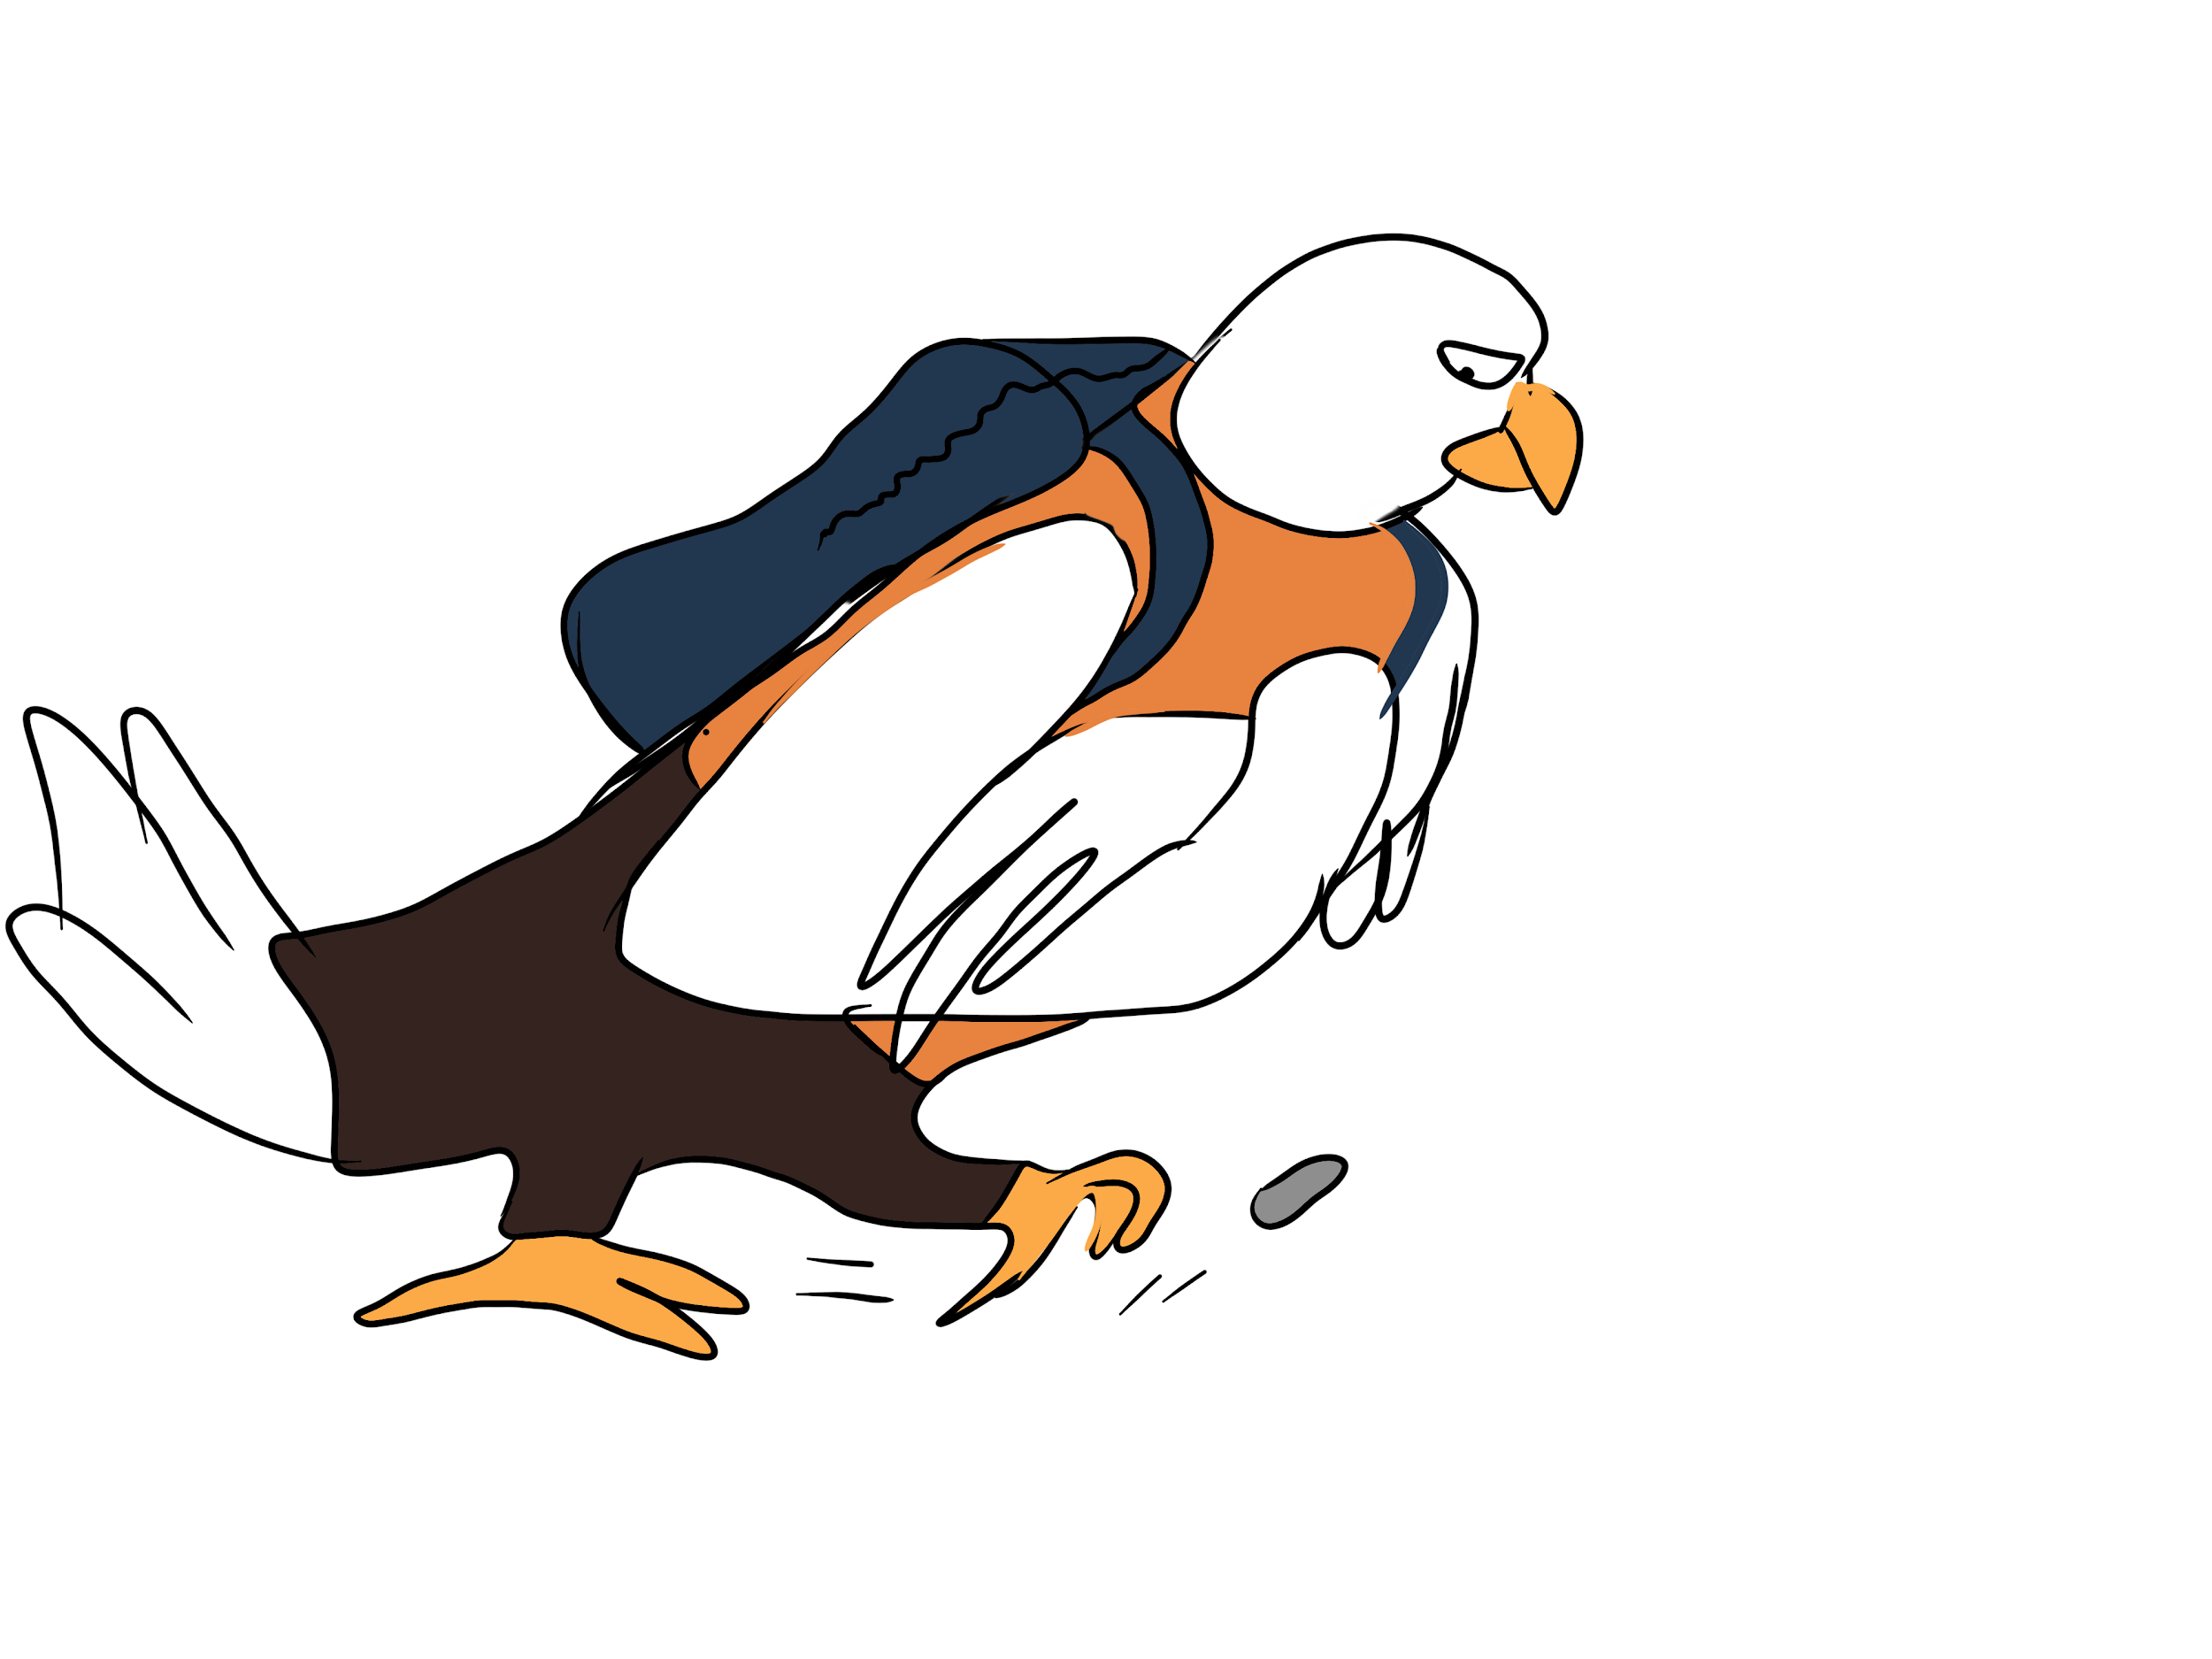
-------------------------------------------------------------------------------------------------------------------------------

Parrot Paula had to give a presentation in front of the class, but she forgot what to say and got tongue-tied.

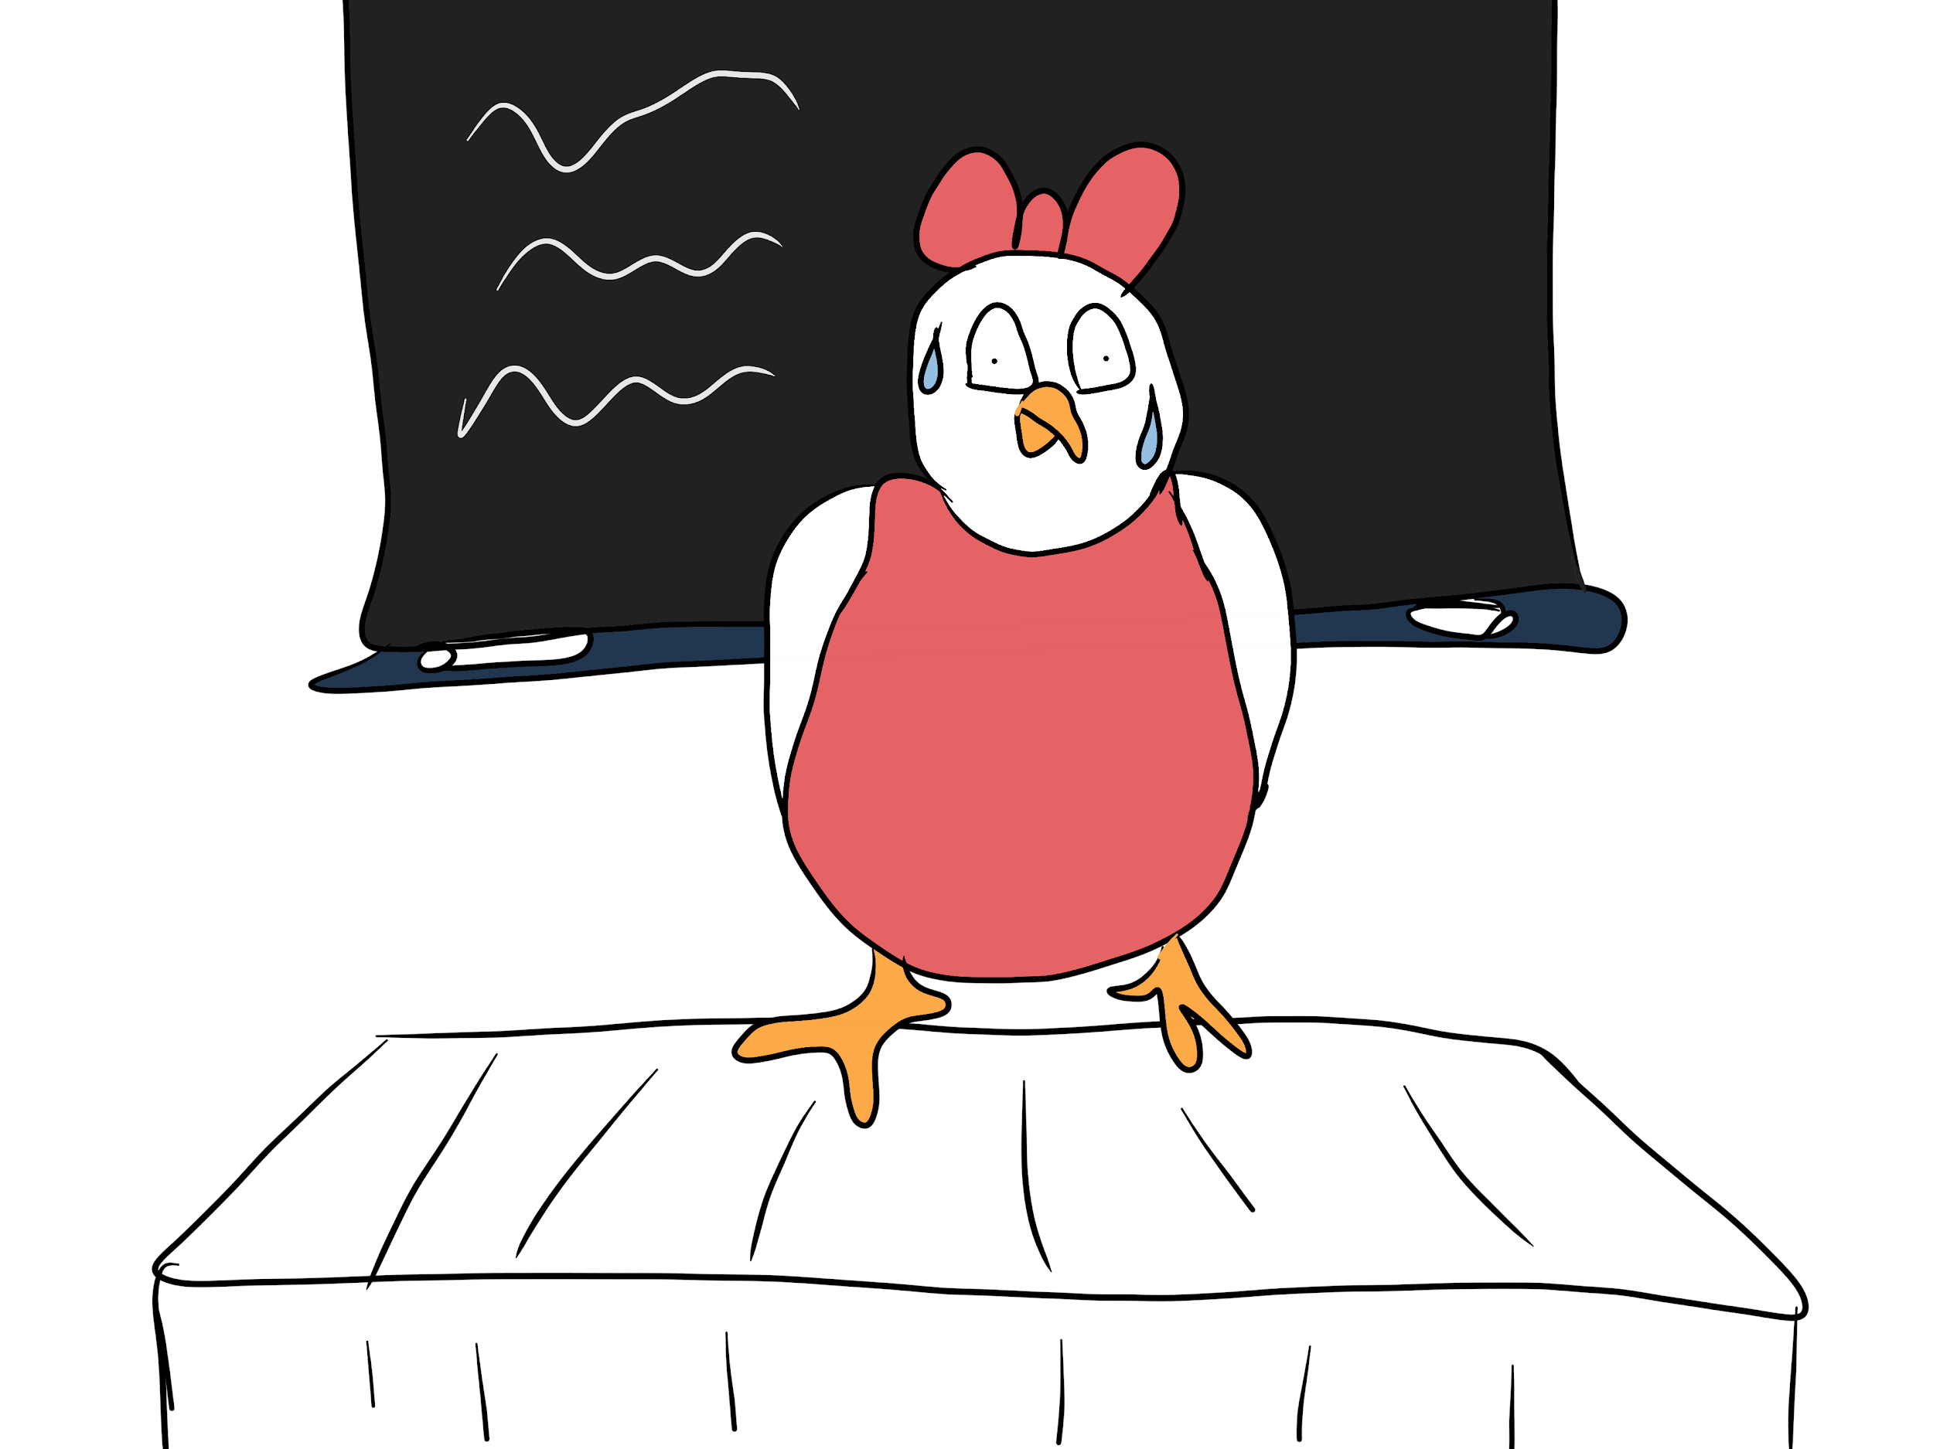

Parrot Lizzy knew all the answers in the lesson. She really tried hard to say her answers by raising her hand very high, but two other classmates were selected and two other classmates answered even without being asked.

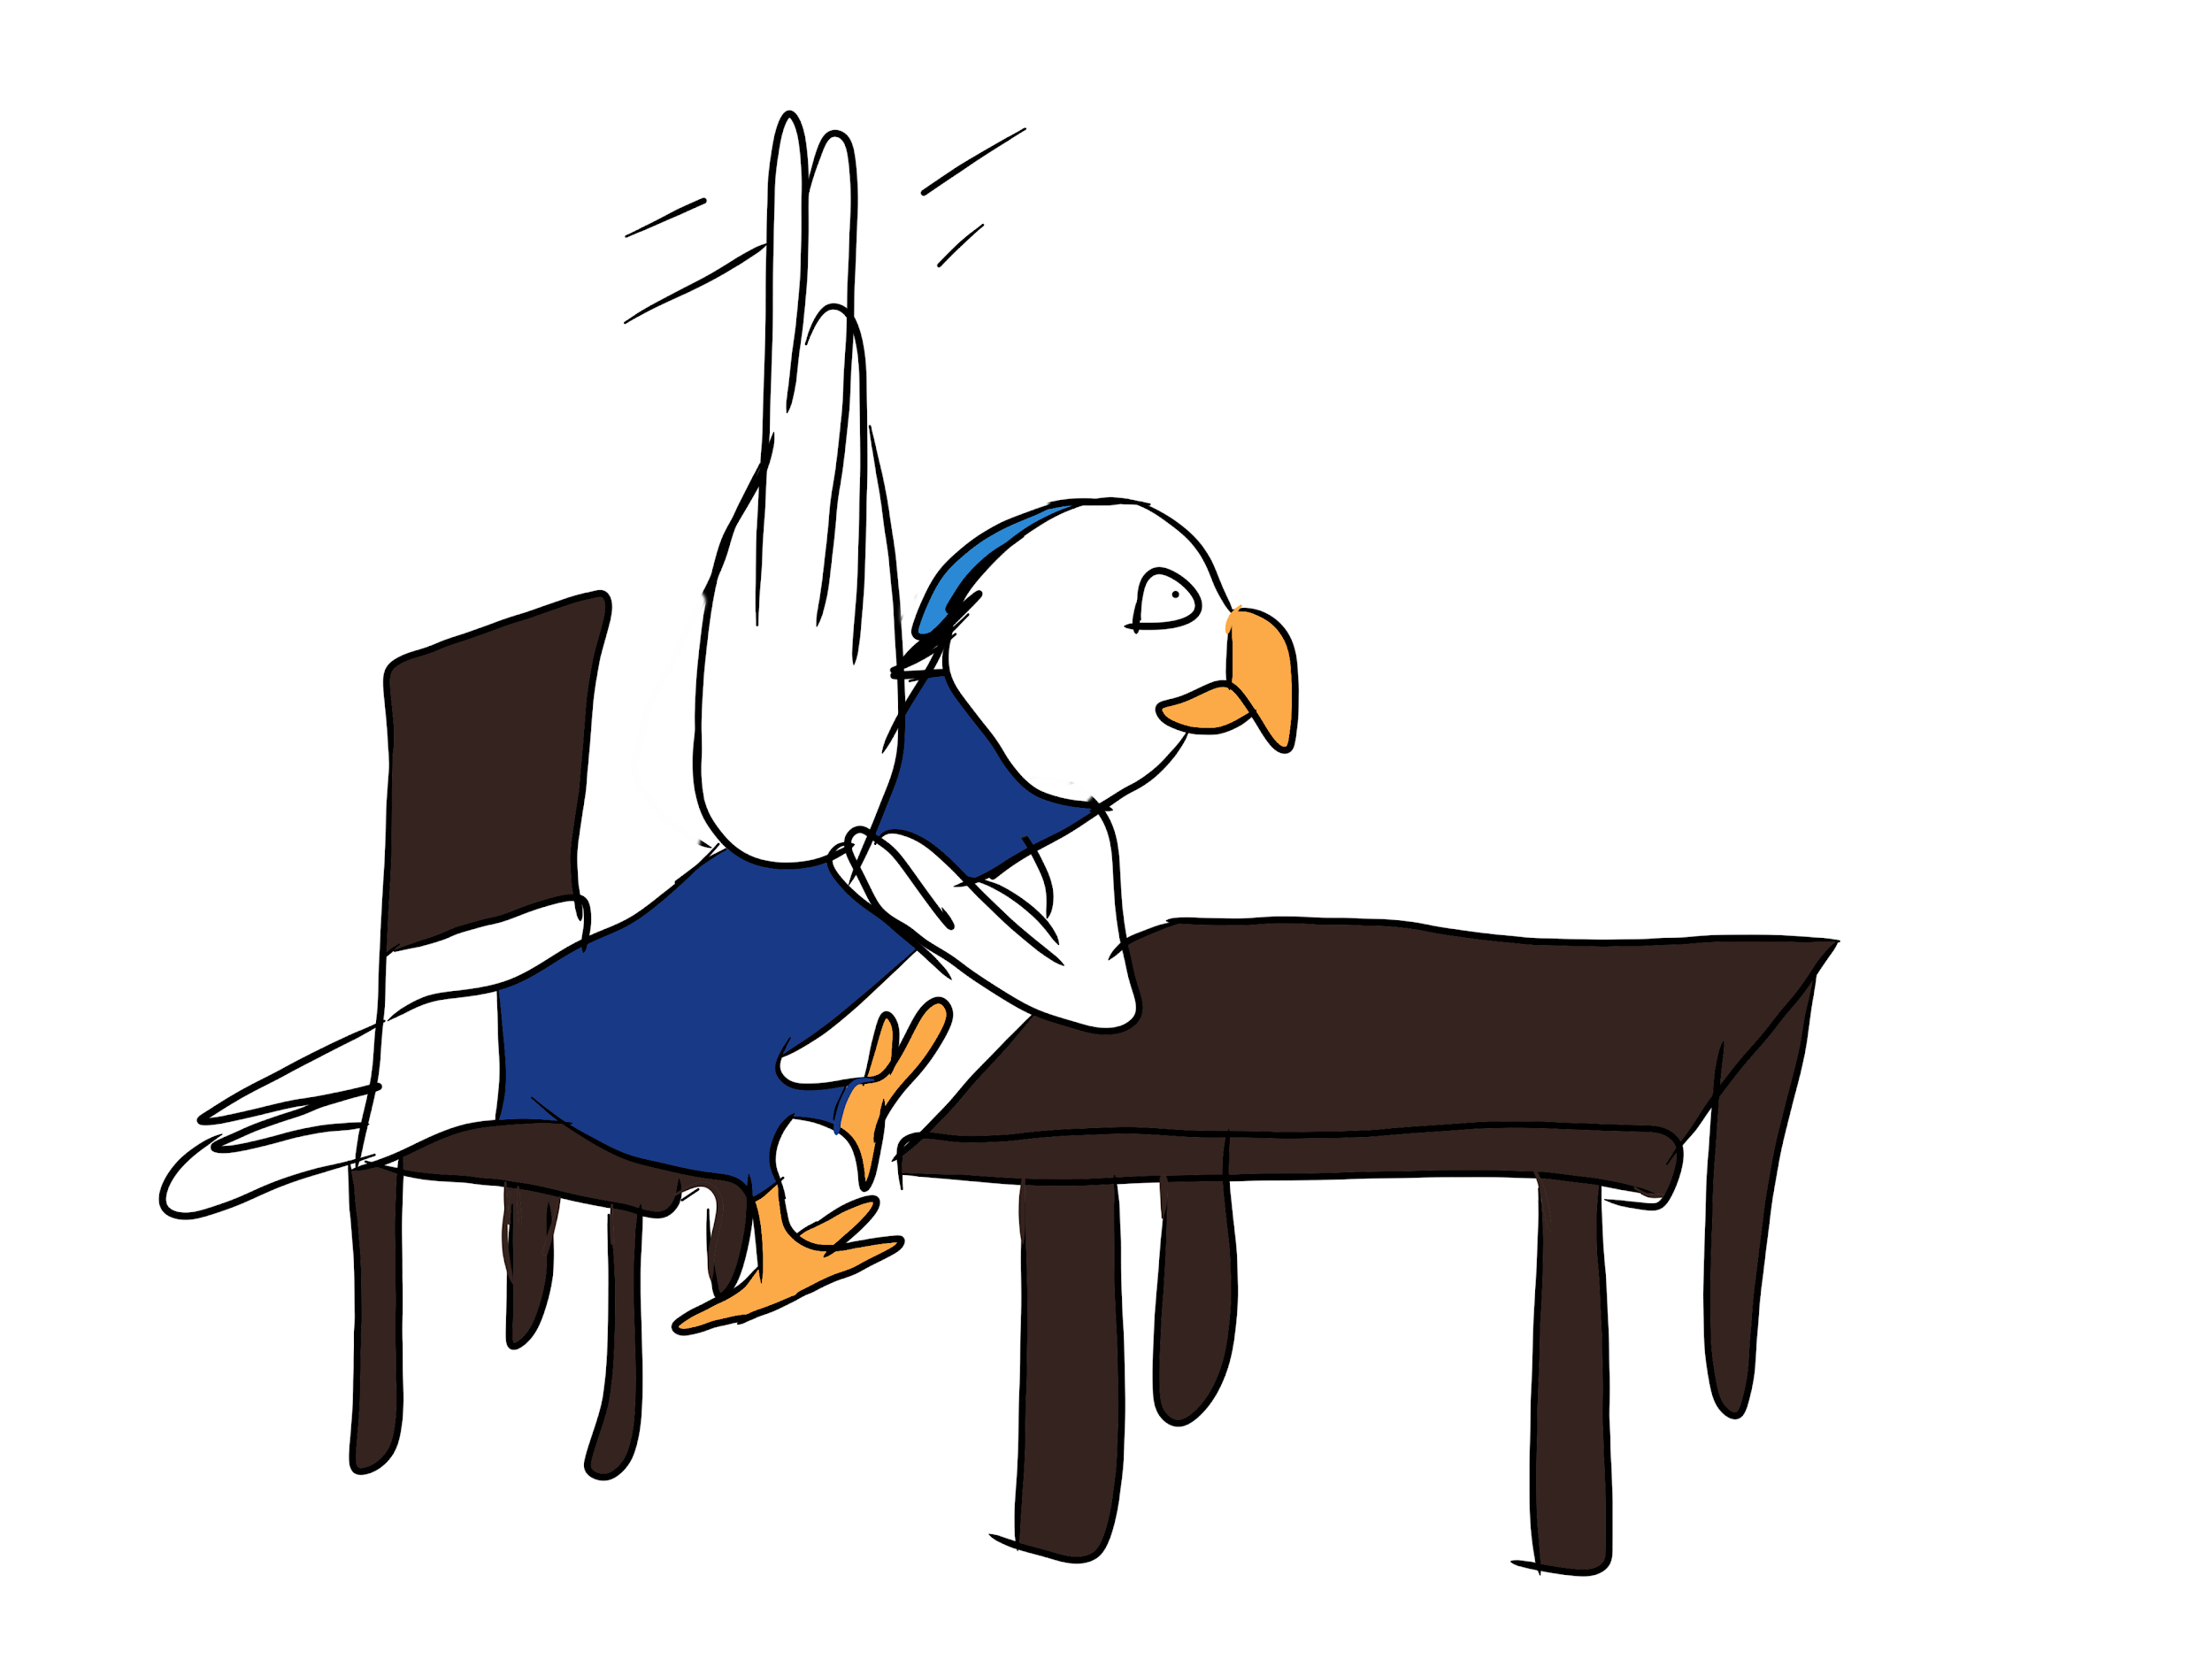

-------------------------------------------------------------------------------------------------------------------------------

Parrot Bobby did something super cool, he made a bicycle kick and scored a goal, but his classmates don’t believe what he said.

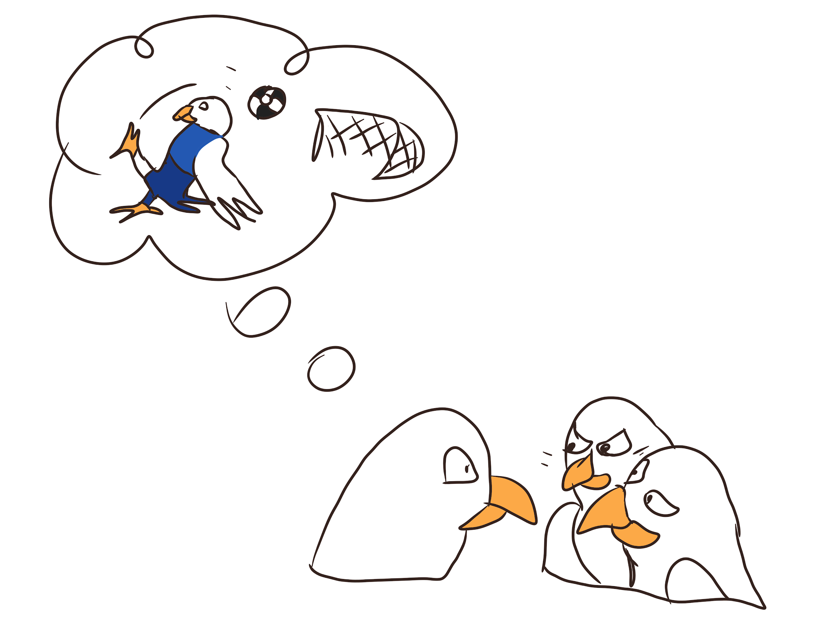
Parrot Lizzy was playing with friends, but while running she fell in the mud and hurt herself a bit. Her friend helped her to the school’s first aid person and helped her clean up.

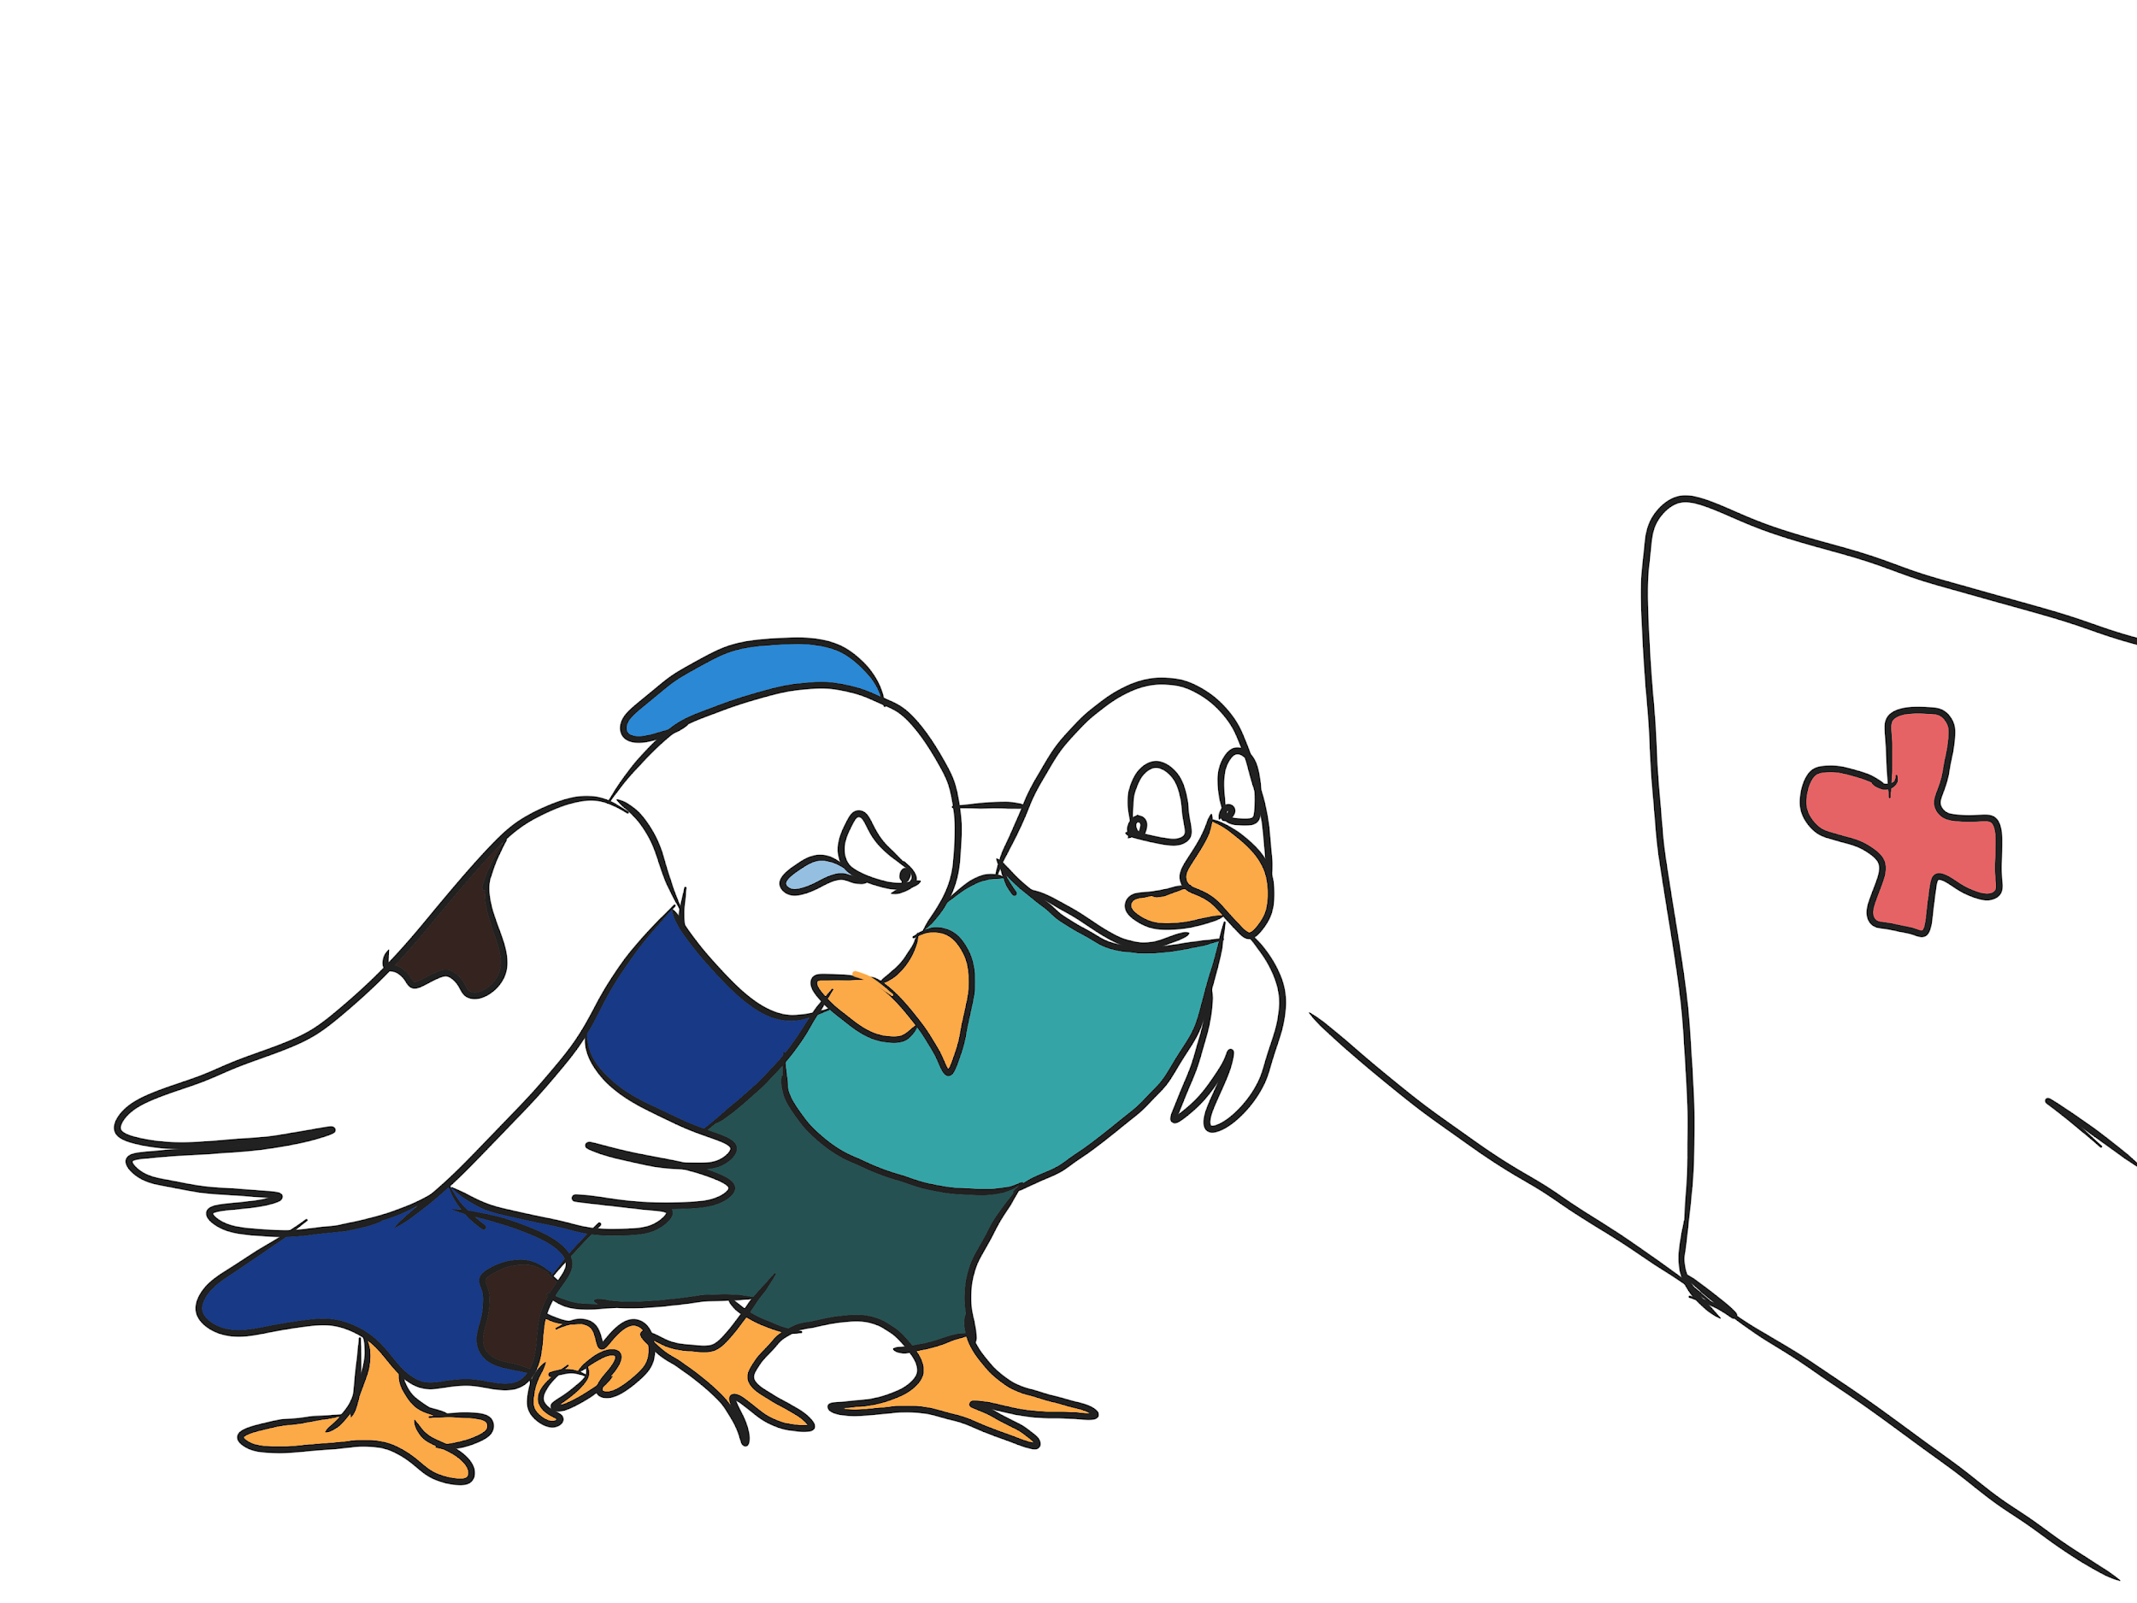

-------------------------------------------------------------------------------------------------------------------------------

Parrot Pedro was not selected by the teacher to play a major part in the musical which the class is going to perform, even though he wanted it.

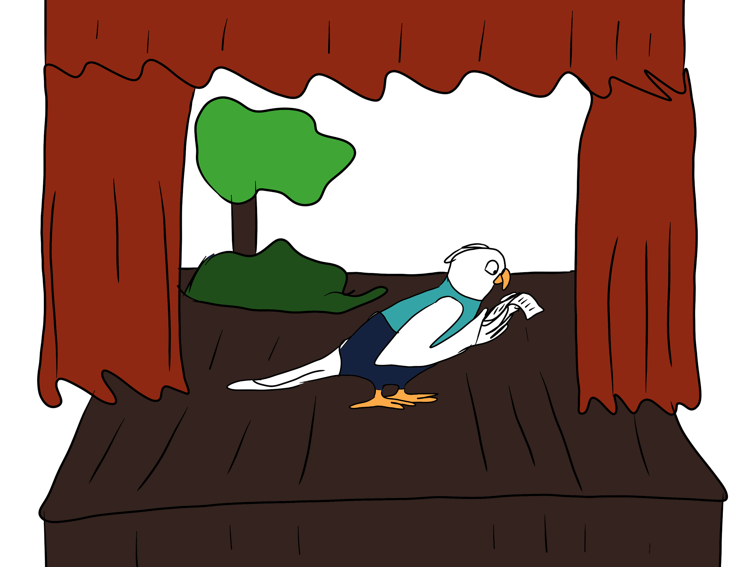
Parrot Bobby realises on Sunday that he has an art assignment due the day after, and it’s too late to go to town to get the necessary materials for it.
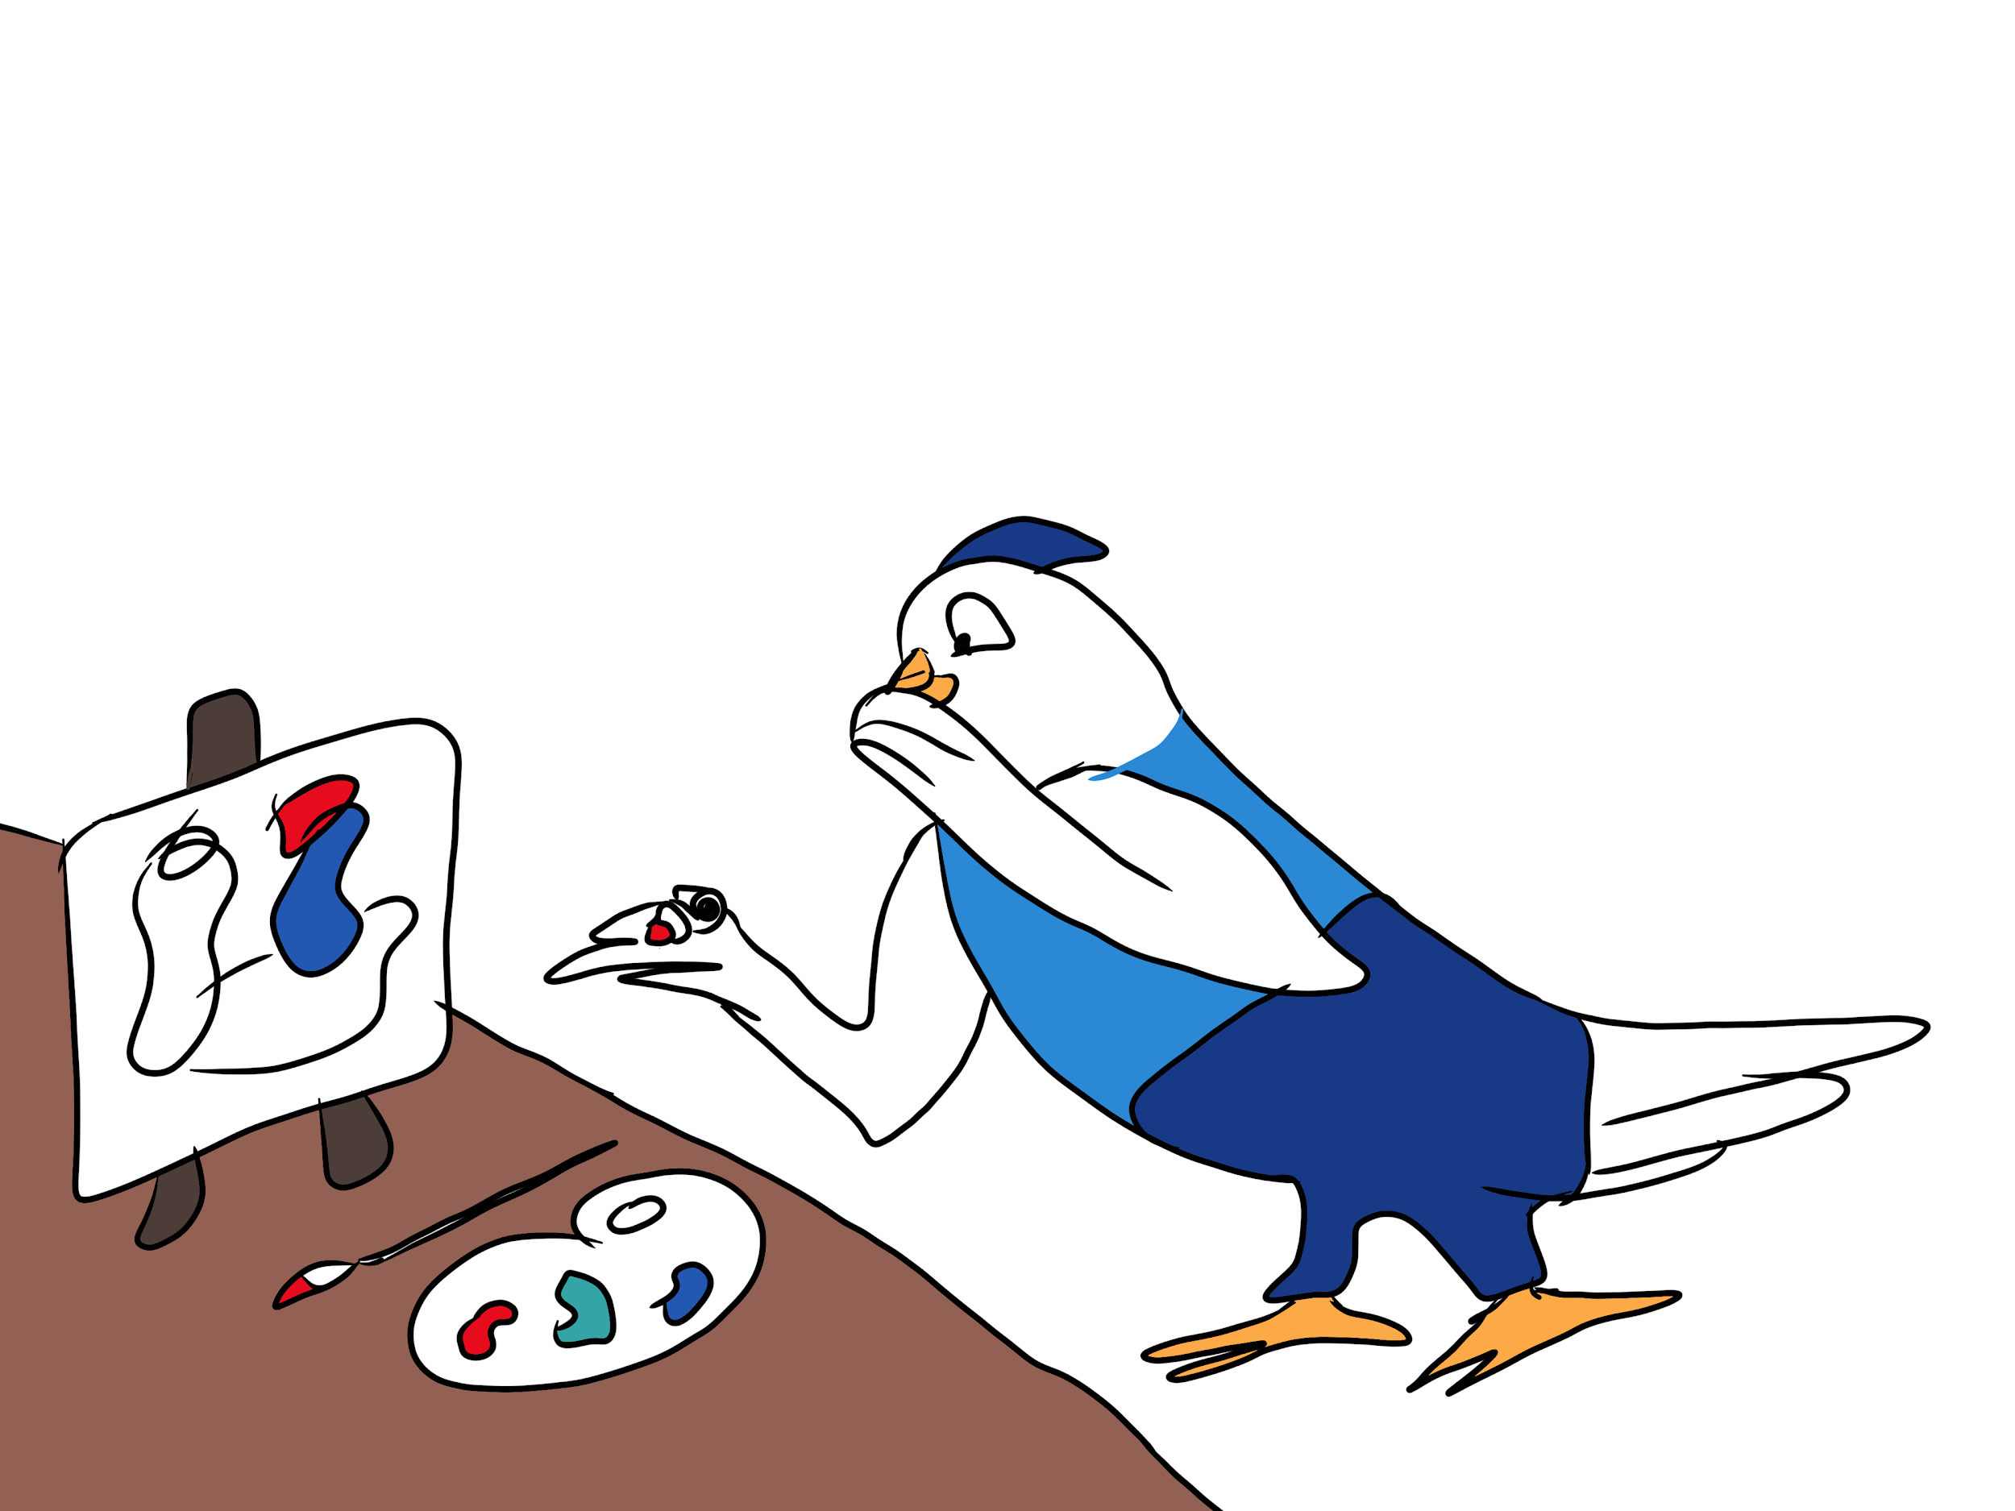
-------------------------------------------------------------------------------------------------------------------------------

Parrot Lizzy had an argument with her best friend. Afterwards she tried calling and texting her but got no response.
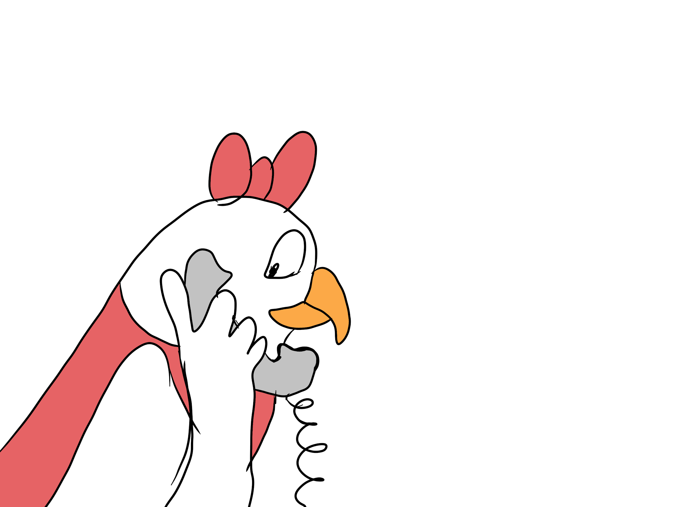

Parrot Pedro is trying really hard to learn how to ride a bicycle, but he’s constantly falling.

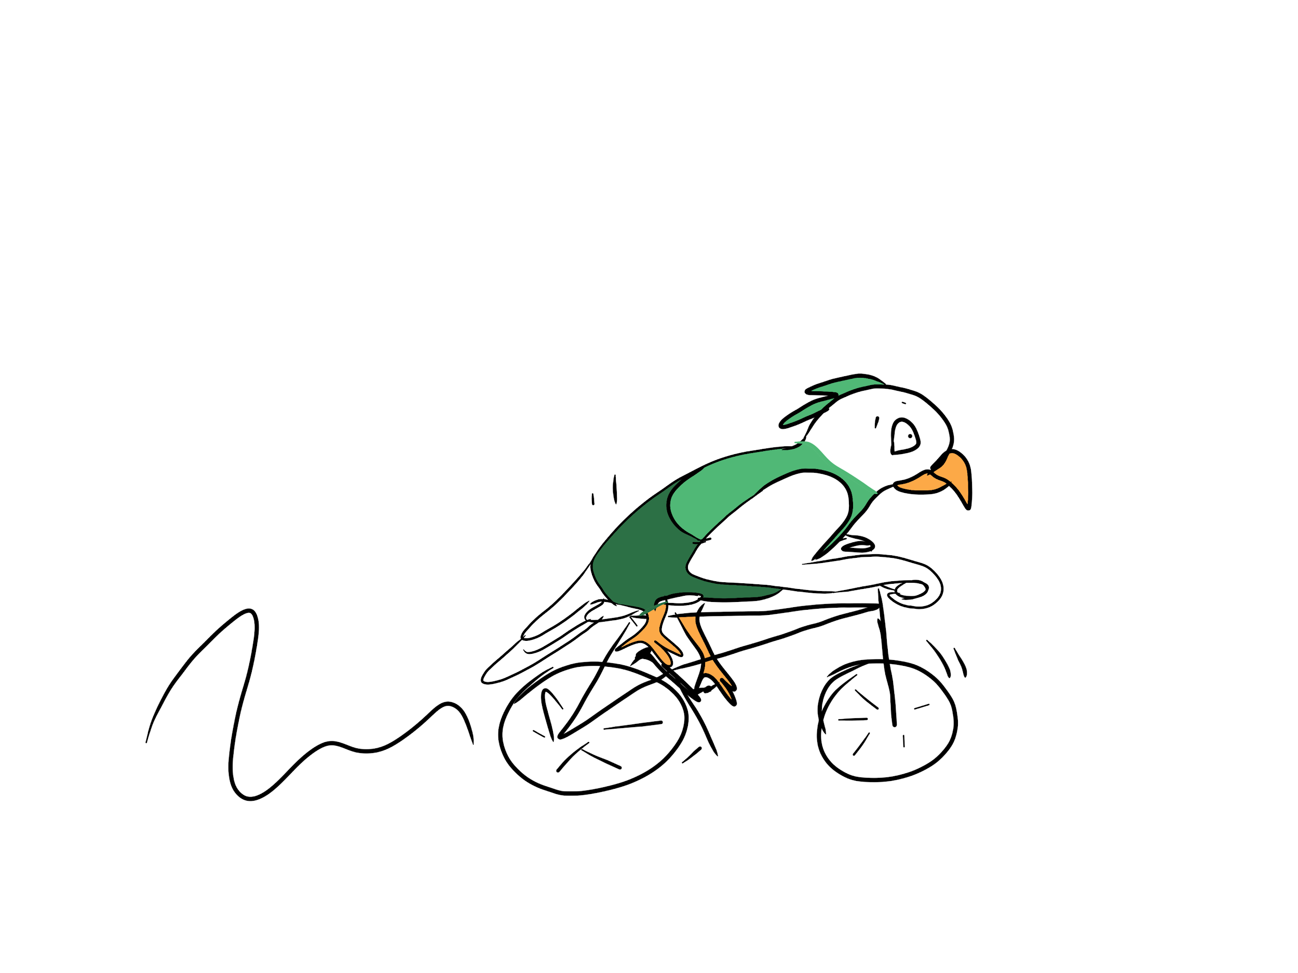

------------------------------------------------------------------------------------------------------------------------------

Parrot Coco has to change to a different school next year.

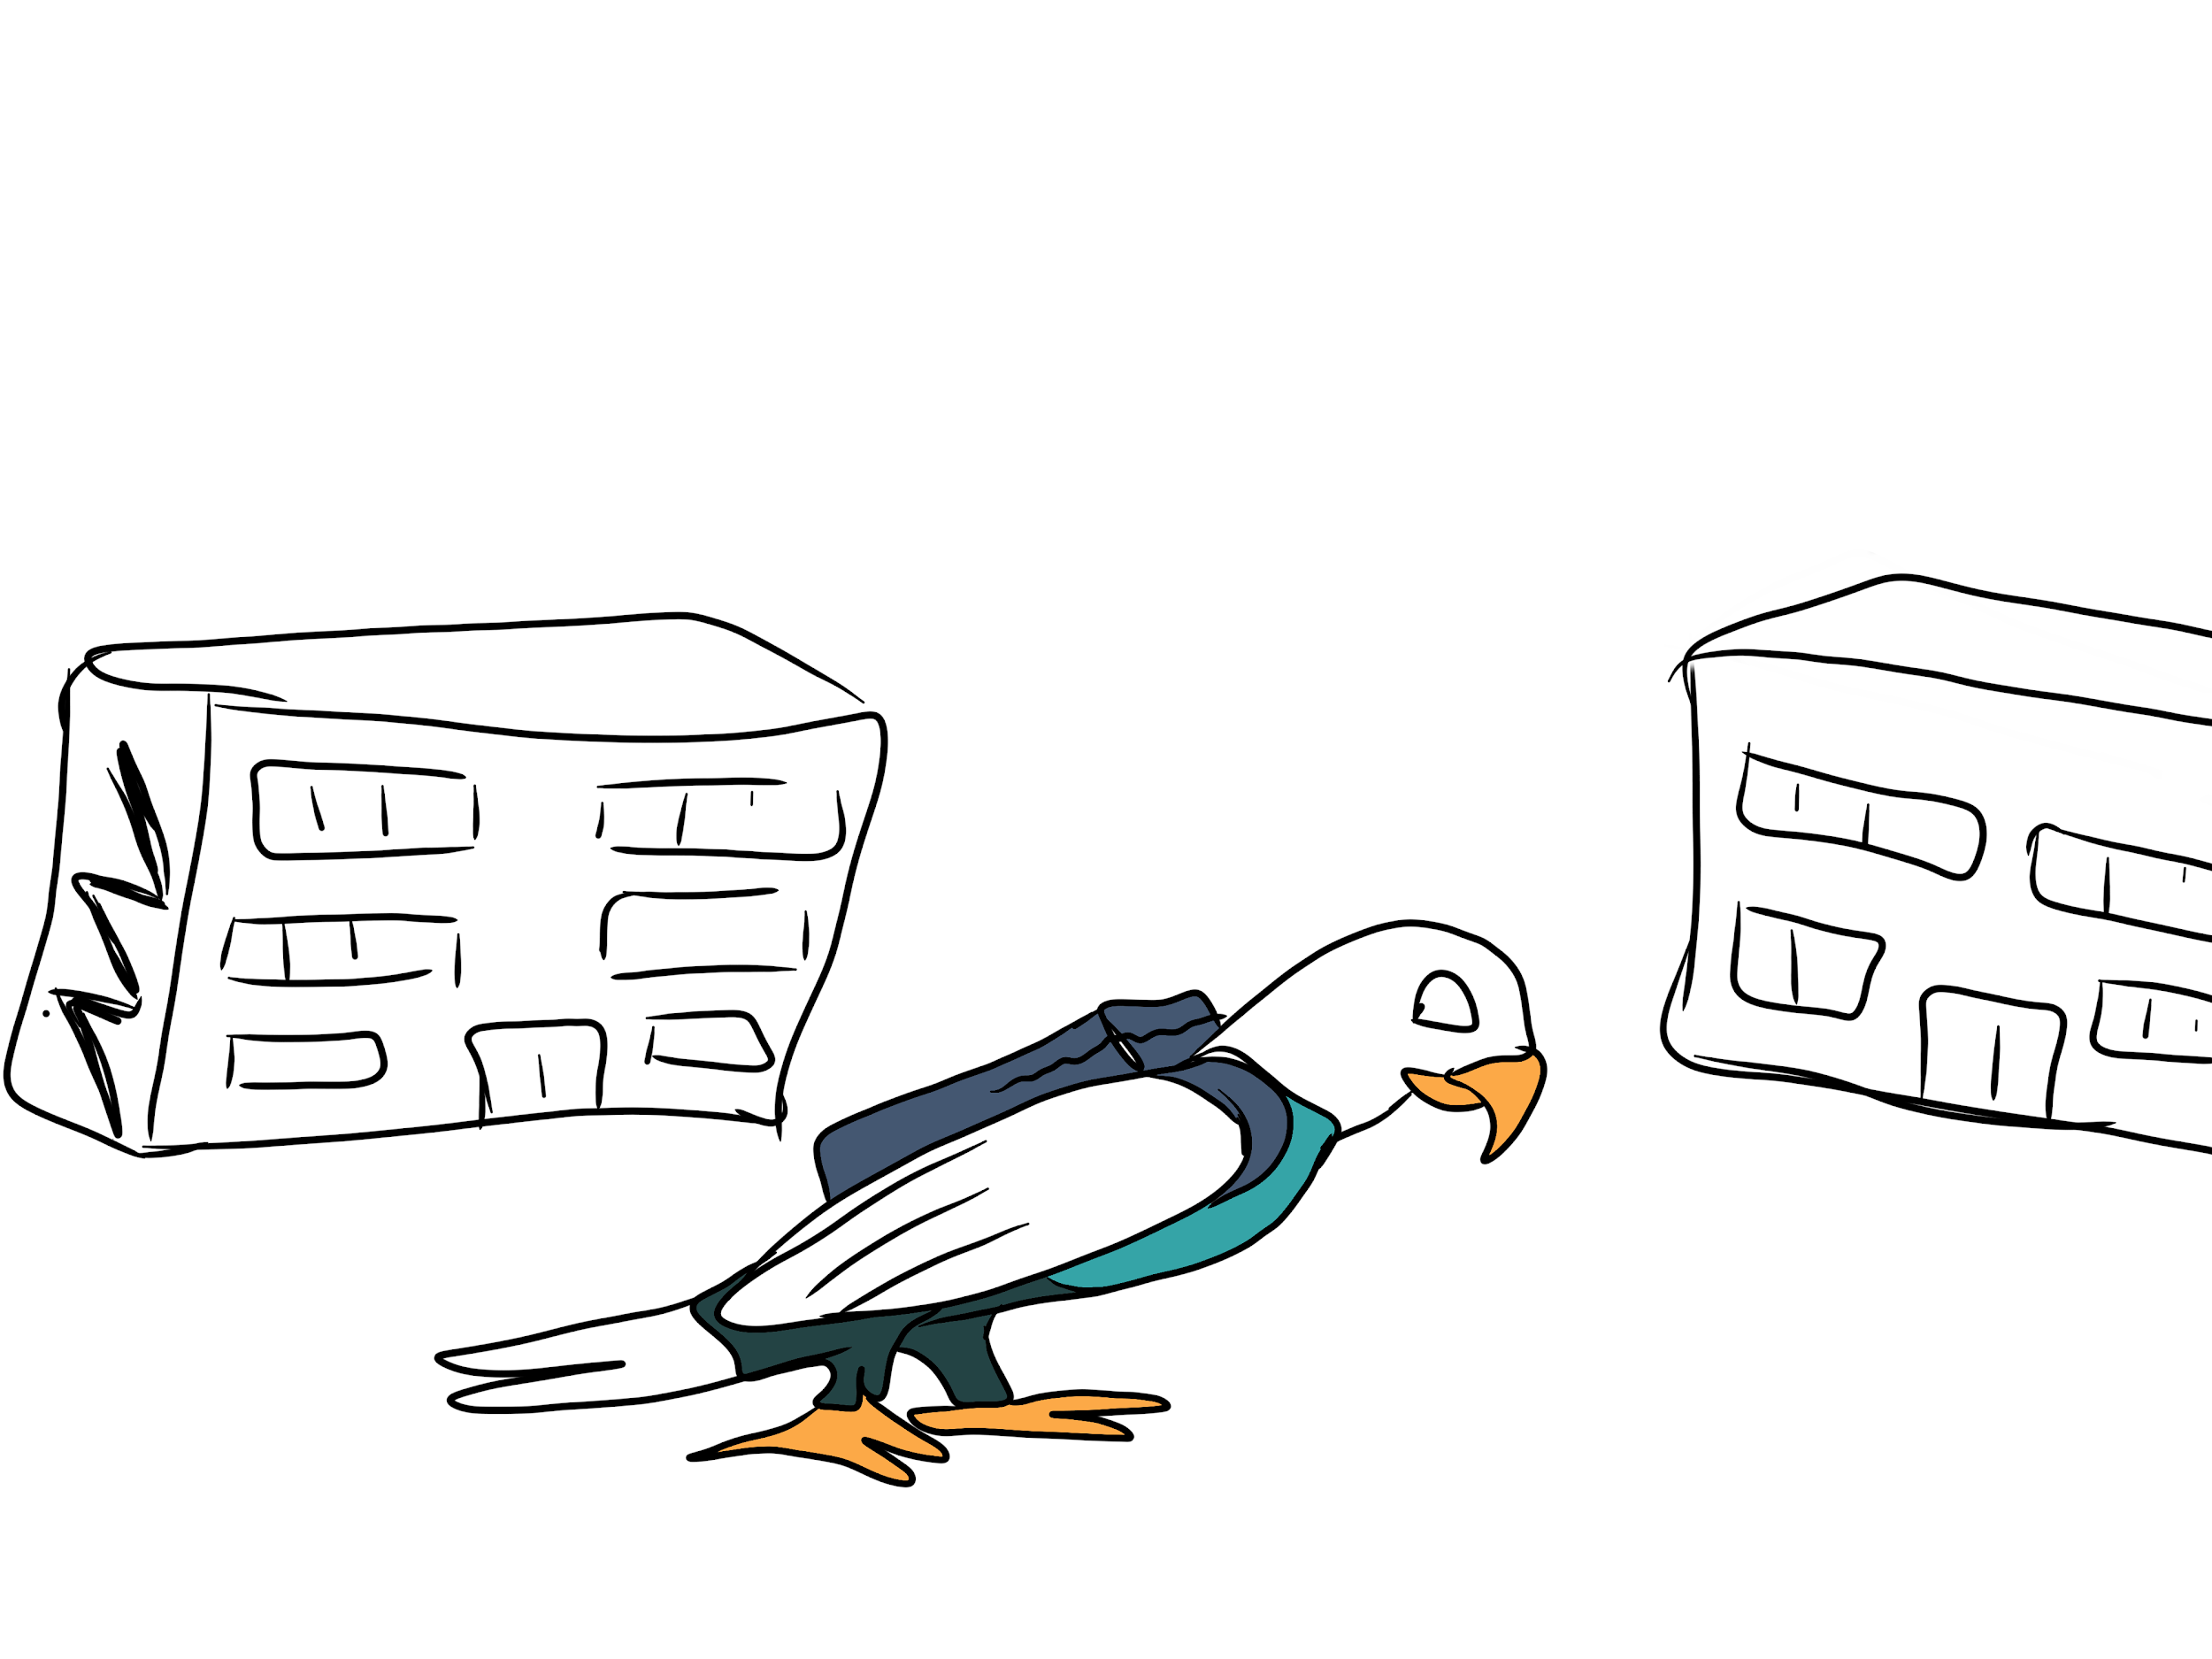

Parrot Paula celebrated her birthday yesterday and the teacher asked how it was. She is disappointed because she did not get the present that she wanted.

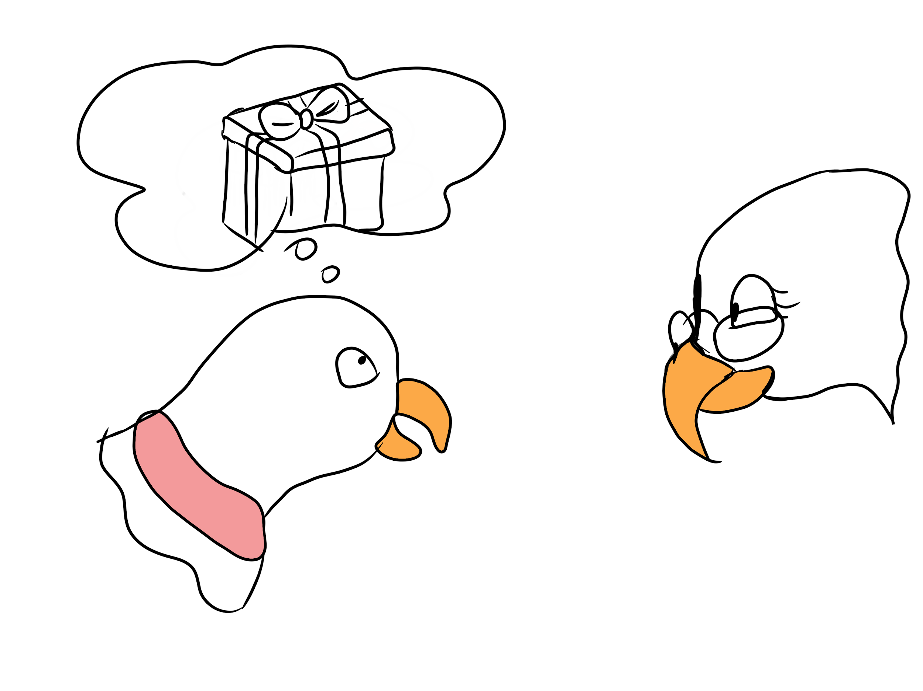

------------------------------------------------------------------------------------------------------------------------------

Parrot Bobby is having lunch and his friend is saying his food looks very weird.

