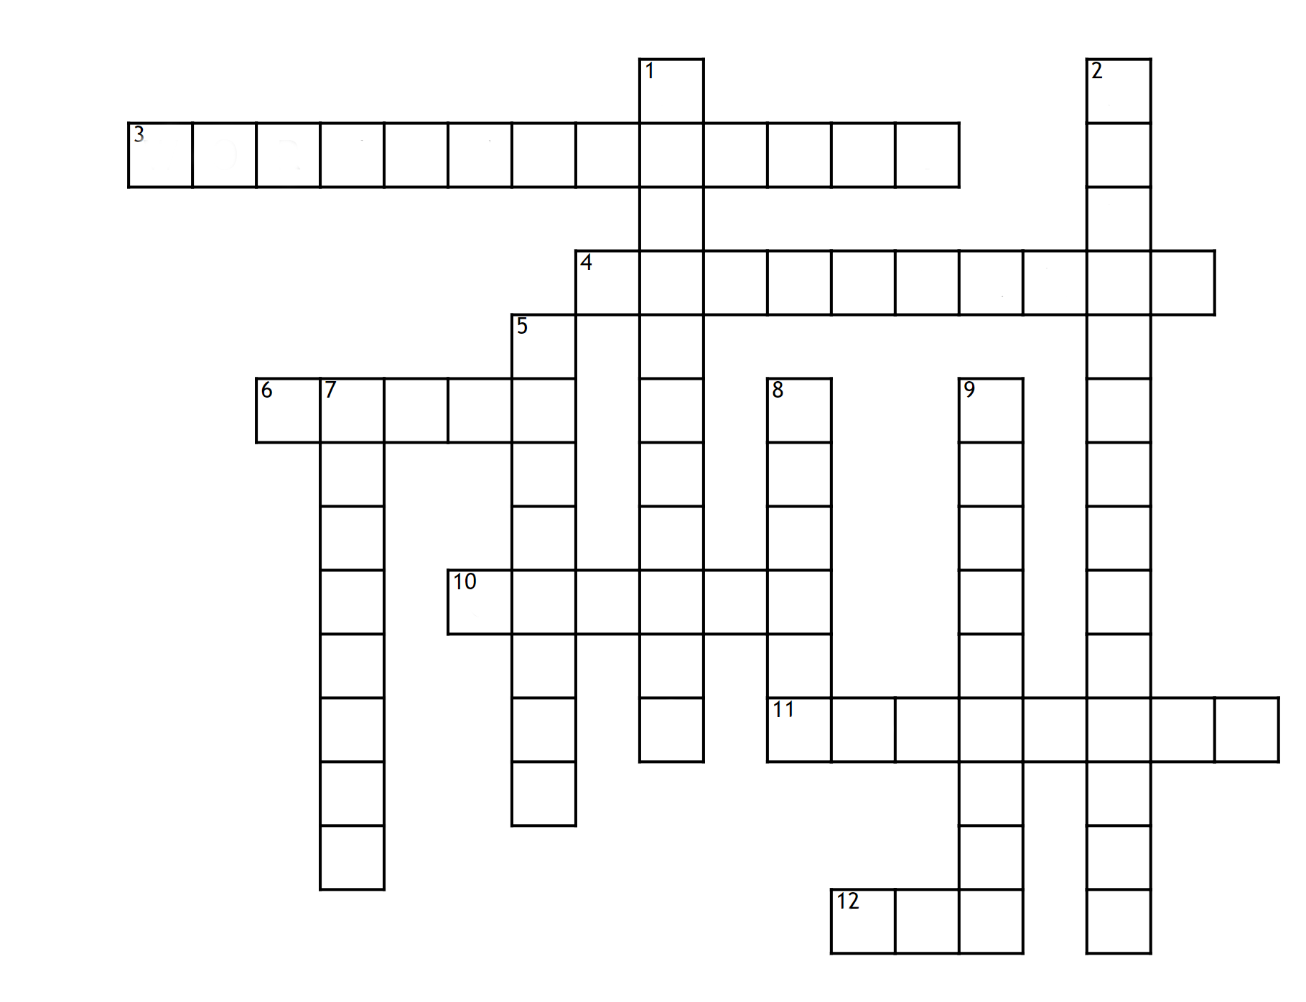

**Across**

**3.** Which memory helps you keeping information in order to solve a problem you’re trying to solve?

**4.** To help memorize, you can study couple of time using ..... .....

**6.** To help memorize, you need to ..... a lot enough to help your brain to be on top of itself

**10.** To help memorize, you can give your brain different ...... of the same information

**11.** The declarative long term memory where you can find all the things that you learn in class

**12.** To help memorize, you can answer a lot of question "..."

**Down**

**1.** The name of the long term memory that you can explain with words

**2.** the name of the long term memory for things that you can’t explain with words

**5.** The declarative long term memory where memories of situations you’ve passed through in the past are stored

**7.** There are two type of memory: the short term memory and the .... .... memory

**8.** The short-term memory is the of the .....

**9.** To help memorize, you can study .........