# Exercice sheet: Controlling the attention

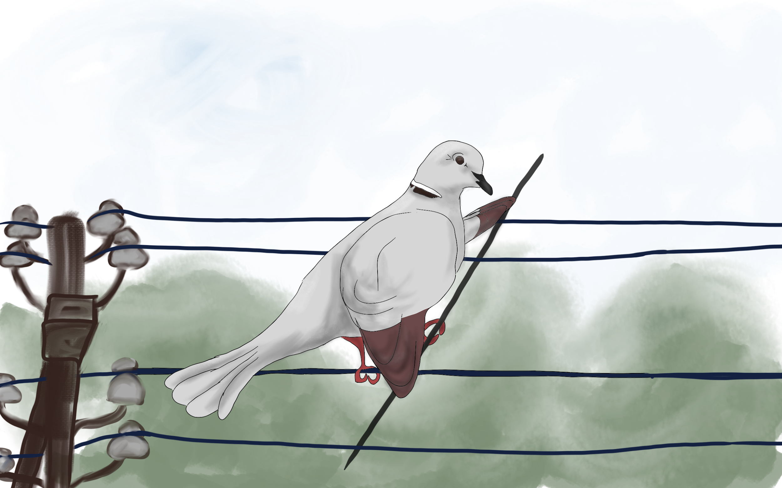

# **Phase 1– Turtledove introduction**

**Turtledove**

“When I need to stay or walk on an electrical cable in a city, like a funambulist, I need to to keep my attention focused so that I don’t not fall. So I am very good at staying focused and I use my concentration for many other things in life.”

# 

Here is a list of a few locations where Maya wants to study. Can you identify which elements at each location could potentially distract her from studying?

**Location 1**

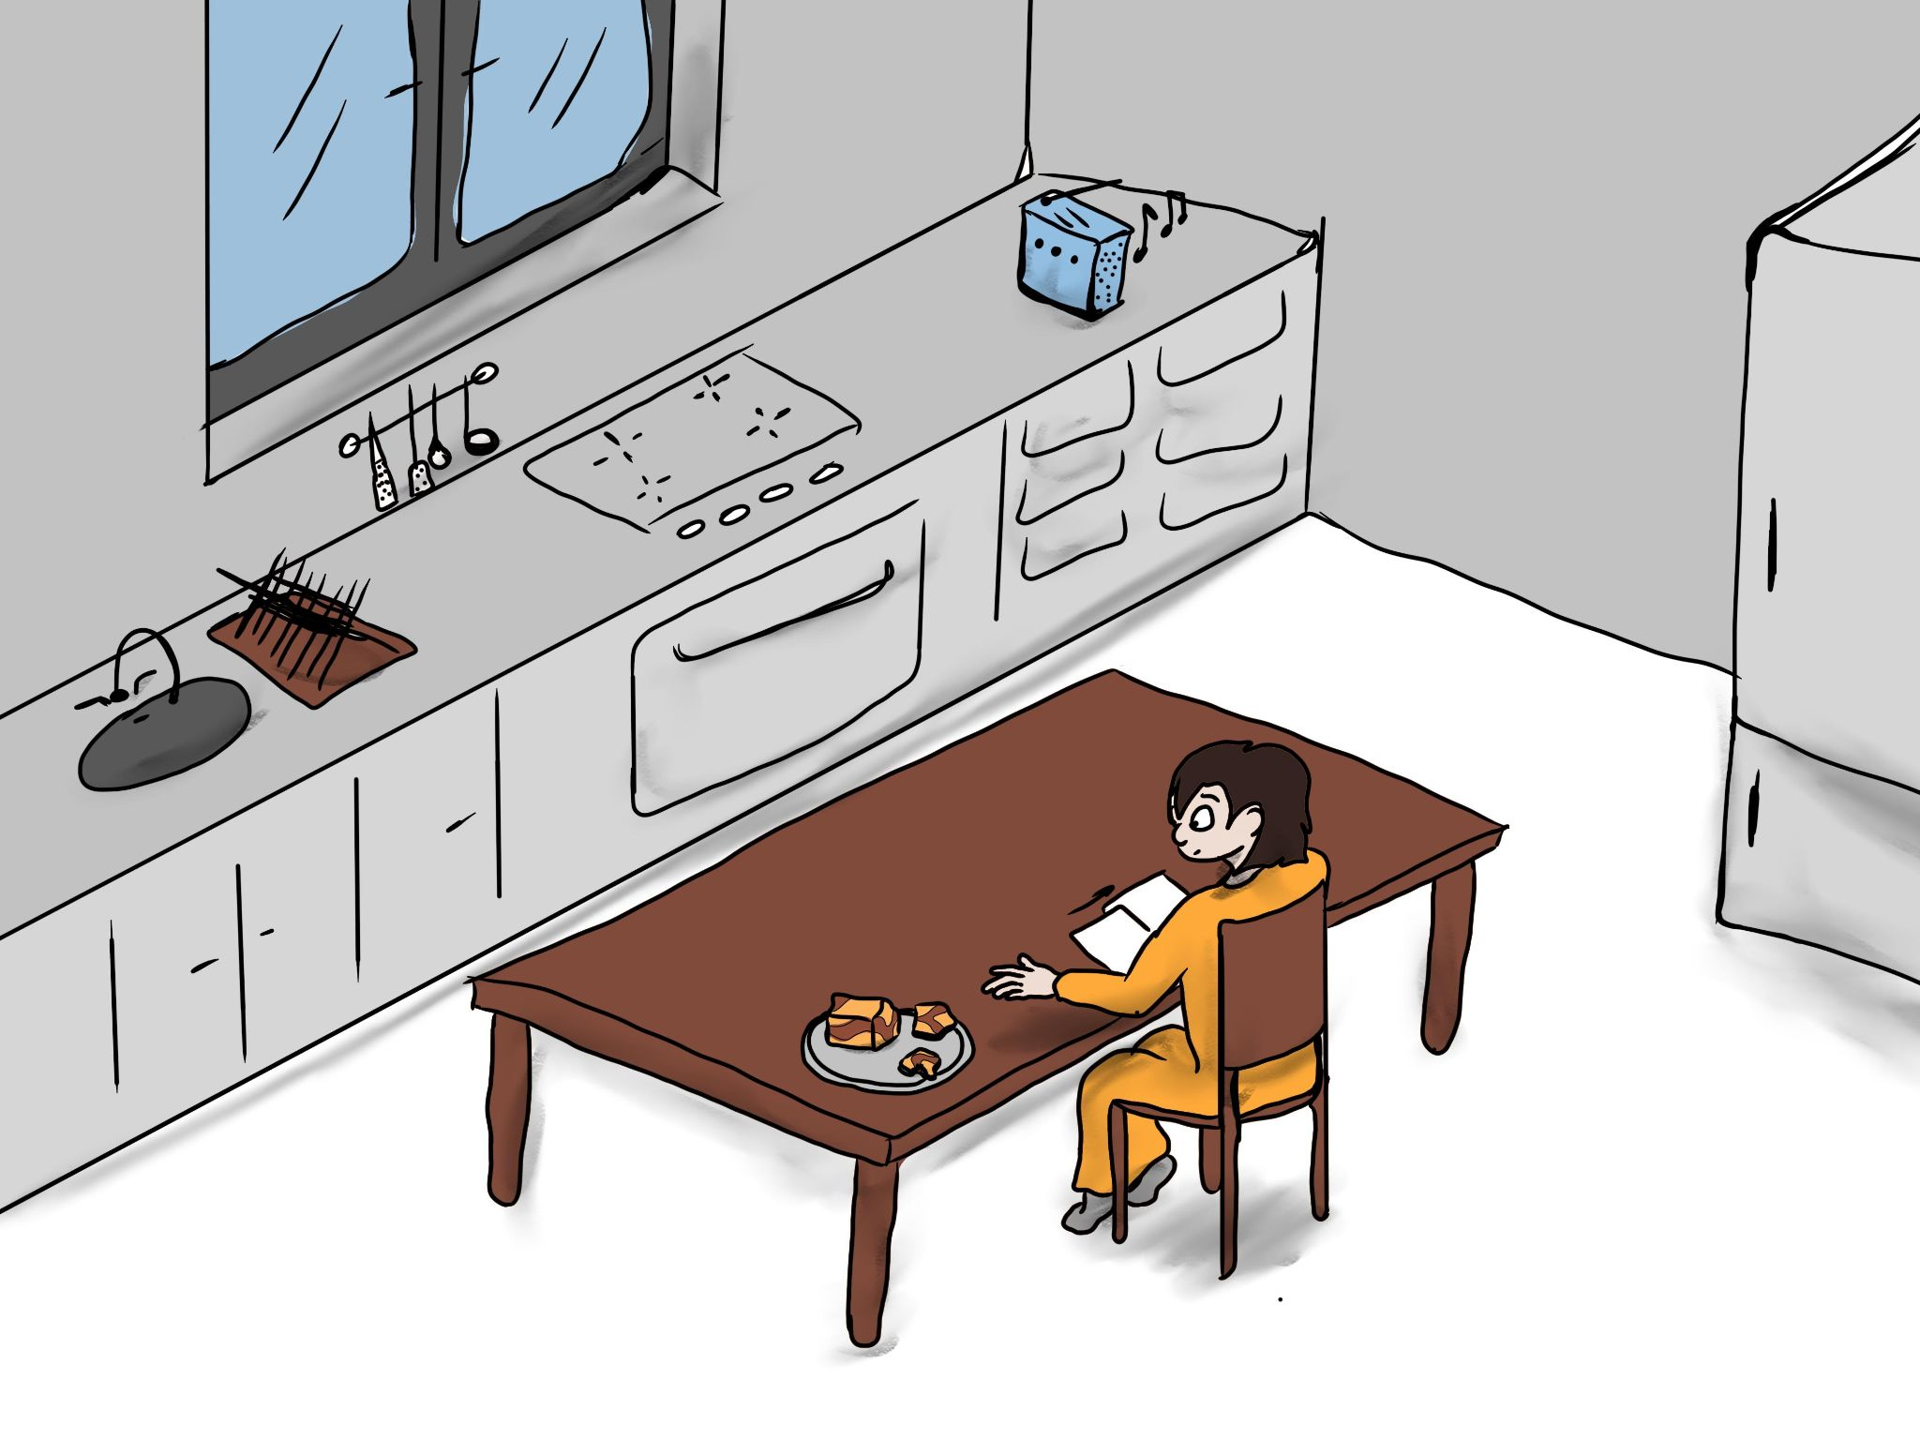

**Location 2**

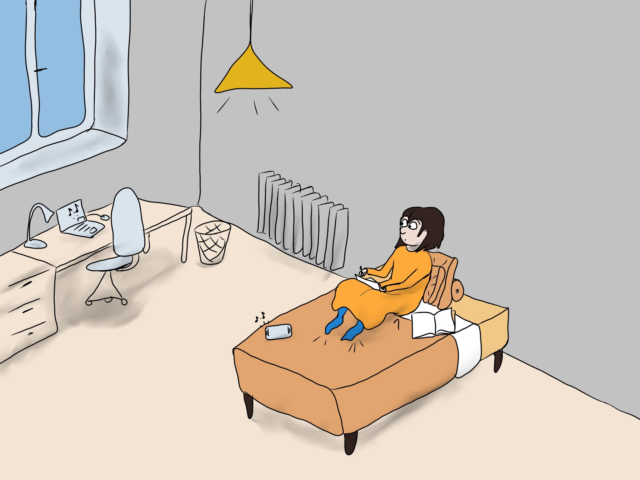

**Location 3**

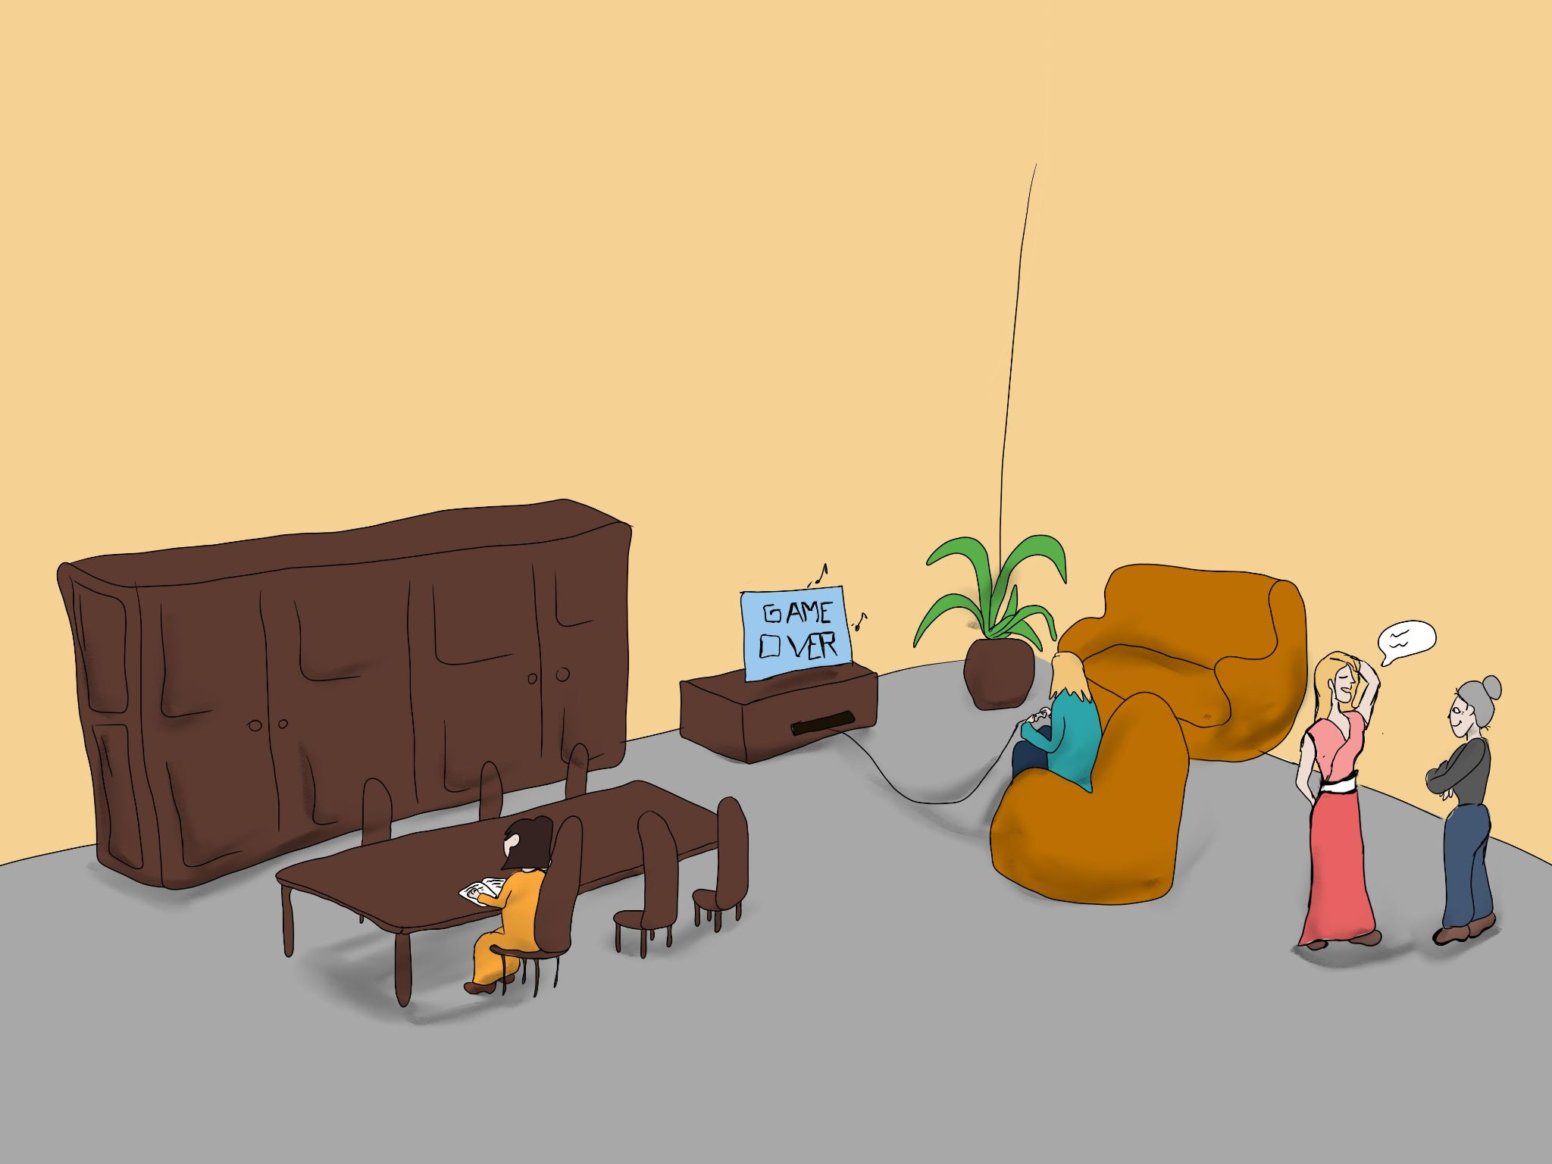

**Location 4**

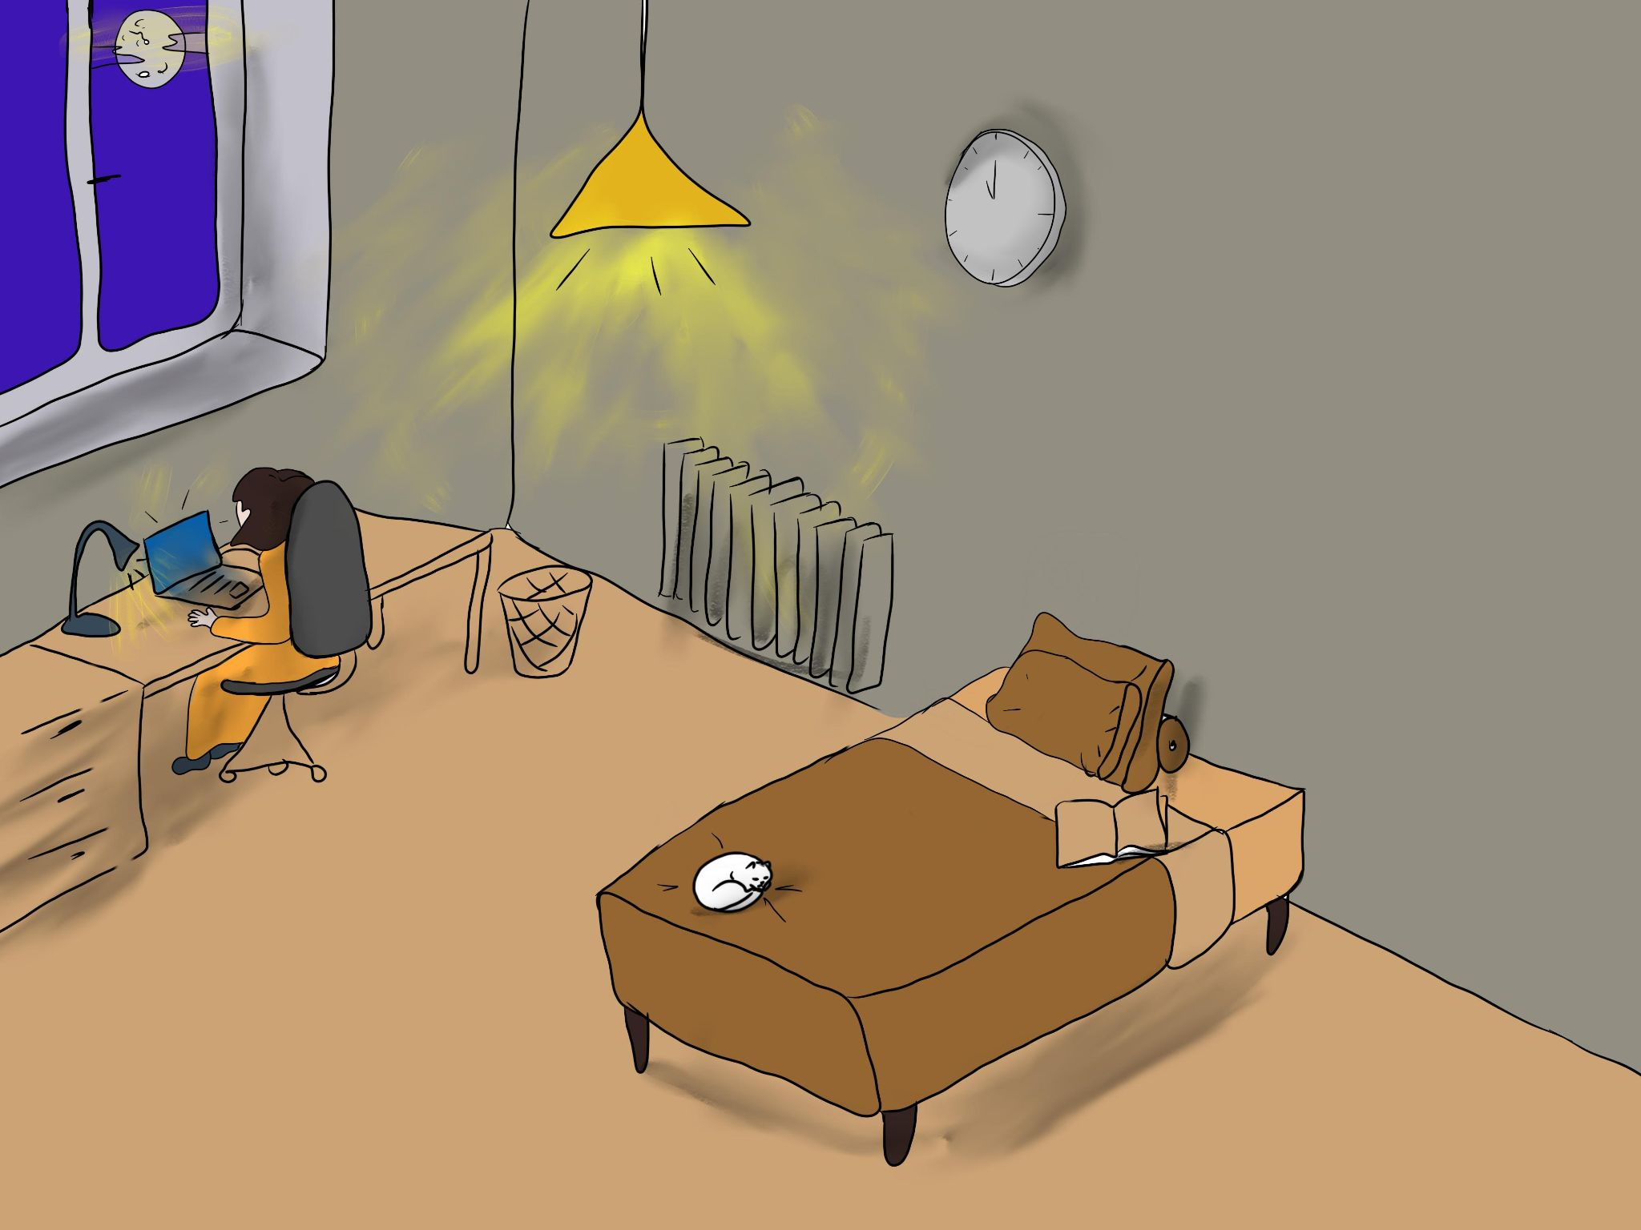

**Location 5**

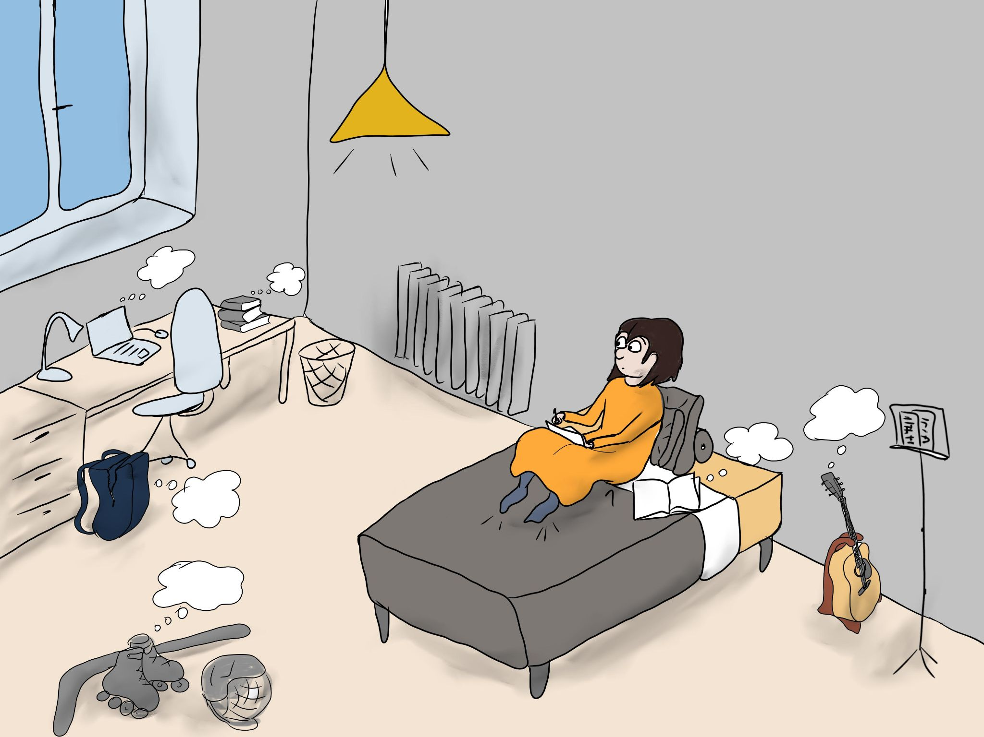

**Location 6**

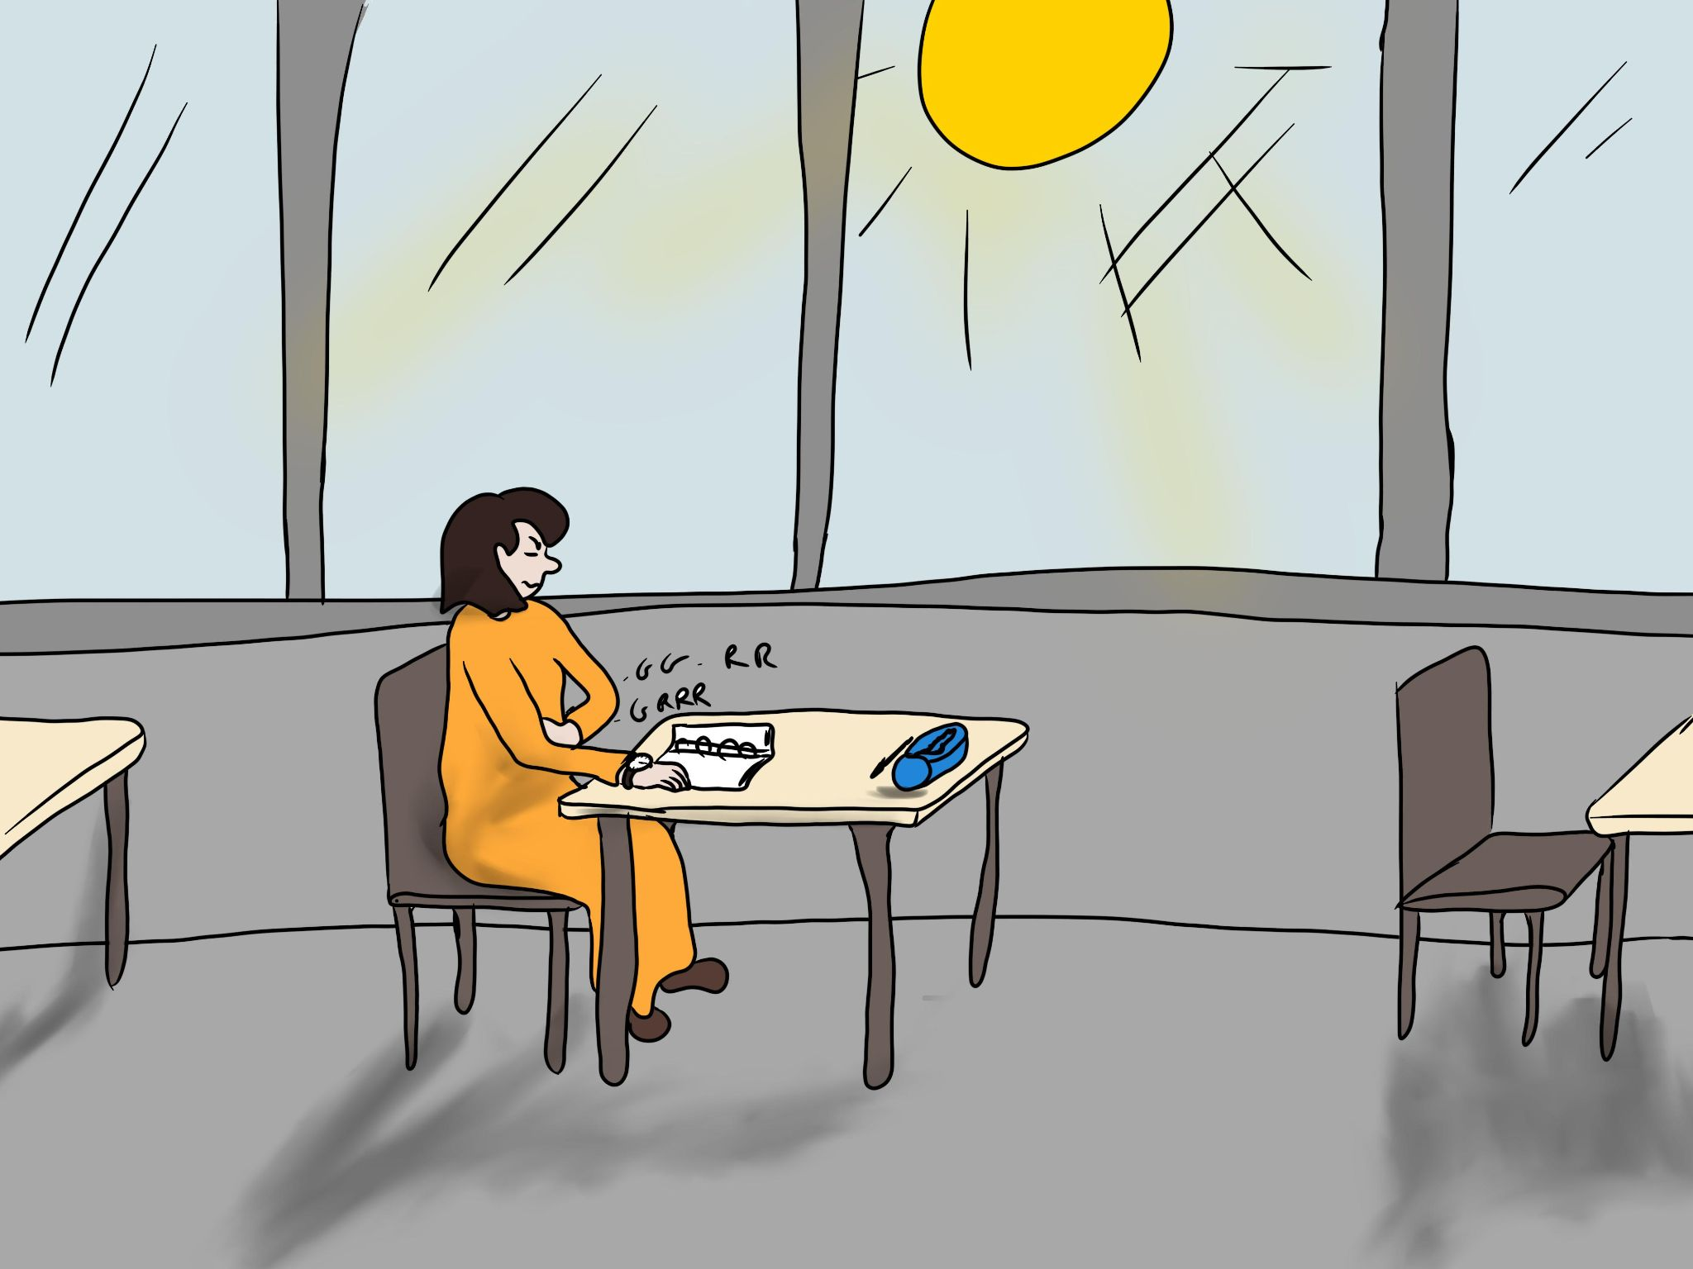

Look at the location again and the elements that you defined as not good for focusing. What could you do to improve the situation?

**Location 1 ………………………………………………………………………………………………**

**Location 2….……………………………………………………………………………………………**

**Location 3….……………………………………………………………………………………………**

**Location 4 ………………………………………………………………………………………………**

**Location 5 ………………………………………………………………………………………………**

**Location 6 ………………………………………………………………………………………………**

Write down the rule 1:

**…………………………………………………………………………………………………**

**…………………………………………………………………………………………………**

**…………………………………………………………………………………………………**

**…………………………………………………………………………………………………**

Find other examples of distractors:

**………………………………………………………………………………………………………....**

**…………………………………………………………………………………………………………**

Make a mindmap or a table with the distractor types: use the above list of distractors (from the 6 locations and the list that you made). Can you group them together? (internal or external …).

**Homework**: take a picture of the location where you usually study. At the next work session discuss with other students which distractors you found at your study location and think how you could make the place where you study less distracting.

# **Phase 2 – Learning how to recognize distractors**

Use the table below to describe the tasks below. Thick appropriate boxes.

|  |  |  |  |  |  |  |
| --- | --- | --- | --- | --- | --- | --- |
| TASK | LONG | SHORT | DIFFICULT | EASY | REPEATING | BORING |
| Reading a book without picture |  |  |  |  |  |  |
| Organising a box of buttons according to their size |  |  |  |  |  |  |
| Learning a poem |  |  |  |  |  |  |
| Enumerating all pair number between 8 and 66 |  |  |  |  |  |  |
|  |  |  |  |  |  |  |
|  |  |  |  |  |  |  |
|  |  |  |  |  |  |  |
|  |  |  |  |  |  |  |
|  |  |  |  |  |  |  |
|  |  |  |  |  |  |  |
|  |  |  |  |  |  |  |

Use blank raws to write down your own homeworks and chores and then describe them as well.

Read the comic about the type of thought.

Choose a couple of your own homework/chores and use the decision tree from the comic to find out how to keep your focus while doing it.

Task 1 ………………………………………...…………………………………………..……………………………………………….

Task 2 ………………………………………...…………………………………………..……………………………………………….

Task 3 ………………………………………...…………………………………………..……………………………………………….

Write down the rule 2

**………………………………………………………………………………………………**

**……………………………………………………………………………………………..**

**………………………………………………………………………………………………**

**………………………………………………………………………………………………**

# **Phase 3 – Defining the difficulty of the task**

# **Phase 4 (30 min) – Learning to perceive fluctuations of your attention**

Write down the rule 3:

**…………………………………………………………………………………………………**

**…………………………………………………………………………………………………**

**…………………………………………………………………………………………………**

**…………………………………………………………………………………………………**

# **Phase 5 – Turtledove conclusion**

# 



**Turtledove:**

When I am on an electrical cable:

* I know what can make me fall (for example, a group of migrating birds passing by in the sky),
* I am able to define the difficulty of the task (for example, the thinner the cable, the more difficult it is to walk on it, or, the longer the cable, the more I need to divide the path into multiple steps so as not to lose the focus).
* At last, I know how to monitor my attention level (for example, by checking whether I’m losing or controlling my balance).